|  |
| --- |
| **DKSH Technology** |
| APS Middleware API Specification for Third Party System (CPVACS, MPS, ACPA-ICK, BOSS, Rental Car System) |

|  |
| --- |
|  |
| |  |  | | --- | --- | | Author | : DKSH | | Issue Date | :30/5/2025 | |  |  | | Version | : 0.23 | |

**Table of Contents**

1. APS API Integration Scenario 4

1.1. ACPB’s Car Parking From ICK to G/F Entry Gate Scenario 4

1.2. ACPB’s Car Parking G/F Entry Gate Scenario 4

1.3. ACPB’s Car Parking for Cabin Drop Off Scenario 4

1.4. ACPB’s Car Parking for Cabin Pick Up Scenario 4

1.5. ACPB’s Car Parking G/F, M/F Exit Gate and M/F Exit Gate in Rental Car Pick Up Area Scenario 5

1.6. ACPB’s Car Parking for Cabin Other Cases Scenario 5

1.7. ACPB’s Car Parking G/F Exit Gate in Rental Car Drop Off Area Scenario 6

1.8. ACPB’s Car Parking G/F Entry Gate in Rental Car Drop Off Area Scenario 6

1.9. ACPB’s Car Parking M/F Entry Gate in Rental Car Pick Up Area Scenario 6

1.10. MPS Create/Update/Retrieve Booking from BOSS Scenario 6

1.11. Update device alert to CPVACS and APS 7

1.12. Shun Hang Road’s Block list control scenario 7

2. API Integration Flow 8

2.1. CPVACS ICK to G/F Entry 8

2.2. CPVACS G/F Entry 9

2.3. CPVACS G/F Cabin Drop Off Area 10

2.4. CPVACS Cabin Pick Up Area 11

2.5. CPVACS G/F, M/F Exit Gate and M/F Exit Gate in Rental Car Pick Up Area 12

2.6. CPVACS Cabin Other Cases 13

2.7. CPVACS G/F Exit in Rental Car Drop Off Area 14

2.8. CPVACS G/F Entry in Rental Car Drop Off Area 15

2.9. CPVACS M/F Entry in Rental Car Pick Up Area 16

2.10. MPS and BOSS Booking Information 17

2.11. CPVACS inform Device Alert to APS 18

2.12. CPVACS Shun Hang Road Access Control 19

3. API Specifications 20

3.1. Grant JWT Token 20

3.2. Refresh JWT Token 20

3.3. CPVACS Enquiry CPA-ICK Information 21

3.4. CPVACS Enquiry Rental Car Information (TBC) 23

3.5. ~~CPVACS Update CPA-ICK Information (Obsoleted)~~ 25

3.6. CPVACS Request MPS Cabin 26

3.7. CPVACS notify Boss Vehicle Enter ACPB 29

3.8. MPS Notify CPVACS Vehicle Arrived at Drop Off Cabin Door 30

3.9. CPVACS Send MPS Arrived Cabin Vehicle Information 31

3.10. CPVACS Enquiry MPS Cabin Status 33

3.11. CPVACS Inform MPS Ready Cabin 34

3.12. MPS Notify CPVACS/BOSS MPS Drop Off Complete 36

3.13. CPVACS Enquiry MPS Vehicle Status 37

3.14. CPVACS Enquiry Vehicle Outstanding Parking Fee 40

3.15. CPVACS Confirm MPS Pick Up Vehicle 41

3.16. MPS Notify CPVACS/BOSS MPS Pick Up Complete 44

3.17. MPS Notify ACPB pick up Rental Vehicle from MPS (Optional) 45

3.18. CPVACS notify Boss Vehicle Exit ACPB 46

3.19. MPS Create Booking Information 47

3.20. CPVACS/BOSS Enquiry Vehicle Tracking Information 50

3.21. BOSS Request Change Booking Information 54

3.22. ~~CPVACS Notify MPS Intercom Turned on at Cabin Door (Obsoleted)~~ 56

3.23. MPS Request CPVACS Cabin Vehicle Information 57

3.24. MPS Send CPVACS Assigned Pick Up Cabin Information 59

3.25. MPS Notify BOSS Vehicle Retrieve from MPS 60

3.26. ~~CPVACS Update MPS Gate Status (Obsoleted)~~ 62

3.27. ~~MPS Request CPVACS CAS/LPRs status (Obsoleted)~~ 63

3.28. MPS Request BOSS Validate Driver Info 65

3.29. MPS update Guidance Monitor Outside Parking Cabin Message 66

3.30. MPS send Cabin Available Status to CPVACS 68

3.31. CPVACS send APS devices alert to MPS 69

3.32. CPVACS check block list in Shun Hang Road 71

## APS API Integration Scenario

### ACPB’s Car Parking From ICK to G/F Entry Gate Scenario

* + 1. ACPA-ICK create Vehicle ACPA-ICK record and may update the record field.
    2. APS Fetch Vehicle ACPA-ICK Information from ACPA-ICK on Schedule.
    3. ICK inform ACPB vehicle was released from ICK and ACPB inform to APS about release.

### ACPB’s Car Parking G/F Entry Gate Scenario

* + 1. Vehicle Arrived G/F Entry Gate and Capture LPN.
    2. Check Vehicle ACPA-ICK Information with LPN.
    3. If vehicle information is matched, request MPS to assign Cabin and Display Information in Display.
    4. If the Vehicle is not a Booking Vehicle, check Vehicle is in the Whitelist.
    5. If the Vehicle is not in the whitelist, check Vehicle Rental Car Information with LPN (TBC).
    6. Open Gate Barrier (Booking/whitelist/rental vehicle) and Create Parking Record (Booking/whitelist vehicle)
    7. Inform BOSS/Rental System (TBC) the “Enter into Car Parking B” Timestamp.

### ACPB’s Car Parking for Cabin Drop Off Scenario

1. MPS Notify ACPB Vehicle Arrived Cabin Area.
2. Enquiry MPS Assigned Cabin Status and display the related information in Display.
3. If vehicle information is matched, request MPS to ready Cabin (Open Cabin Door).
4. Inform BOSS the “Car Parking Transfer Cabin” Timestamp with Arrival status.
5. Patron wait the Cabin Door Open and Update Parking Record.
6. MPS scan Patron Passport and validate by BOSS API.
7. MPS Notify ACPB that the Cabin Door (Storage Side) opens, and the process has been completed.
8. Inform BOSS the “Car Parking Transfer Cabin” Timestamp with Park status.

### ACPB’s Car Parking for Cabin Pick Up Scenario

1. Patron arrived at Kiosk to start the checkout process.
2. Patron enter the LPN or scan the booking QR code from Kiosk.
3. ACPB capture booking ID from QR code.
4. ACPB enquiry MPS the vehicle parking record which is matched with the input LPN or booking ID.
5. ACPB request BOSS to validate the patron information.
6. If the patron information is valid, ACPB display vehicle status on the Kiosk.
7. Patron confirm to pickup the vehicle from Kiosk.
8. ACPB enquiry about any outstanding parking fee with this vehicle from BOSS.
9. Settle any outstanding parking fee with Credit Card or Octopus online Terminal.
10. After the patron settles the payment, request MPS to assign retrieval cabin to check out vehicle.
11. Inform BOSS the payment amount and status.
12. Related confirmed information will be shown on the displays.
13. Retrieval cabin is ready and patron picks up the vehicle.
14. When retrieval cabin exit door opens, MPS inform BOSS and ACPB about the timestamp to update the parking record.

### ACPB’s Car Parking G/F, M/F Exit Gate and M/F Exit Gate in Rental Car Pick Up Area Scenario

1. Vehicle Arrived G/F or M.F Exit Gate and Capture LPN.
2. Enquiry Vehicle Status in MPS with LPN.
3. If the Vehicle is not a Booking Vehicle, check Vehicle is in the Whitelist.
4. If the Vehicle is not in Whitelist, check Vehicle Rental Car Information with LPN (TBC).
5. Open Gate Barrier if the Vehicle is Booking/Whitelist/Rental Vehicle.
6. If vehicle information is matched, display Information in Display.
7. Open Gate Barrier. Update Parking Record and inform BOSS/Rental System (TBC) the “Exit from Car Parking B” timestamp.

### ACPB’s Car Parking for Cabin Other Cases Scenario

#### Detect Vehicle

1. MPS need to retrieve vehicle information stored at the cabin under different scenarios.
2. MPS request ACPB retrieve vehicle information stored at the cabin.
3. ACPB capture vehicle stored at the specific cabin and refine the LPN.
4. If LPN matched with the queuing vehicle and with other conditions, MPS send assigned pickup cabin information to ACPB.
5. ACPB update the assigned cabin information to the displays.

#### Vehicle Retrieval

1. MPS retrieve the vehicle for special cases e.g., patron leave the handbag on the car.
2. MPS inform APS the "Vehicle Retrieval" timestamp.
3. APS inform BOSS the "Vehicle Retrieval" timestamp.

### ACPB’s Car Parking G/F Exit Gate in Rental Car Drop Off Area Scenario

1. Rental Vehicle Arrived G/F Exit Gate in Rental Car Drop Off Area and capture LPN.
2. Check Vehicle Rental Car Information with LPN (TBC).
3. If vehicle information is matched, display Information in Display (TBC).
4. Open Gate Barrier and Update Parking Record.

### ACPB’s Car Parking G/F Entry Gate in Rental Car Drop Off Area Scenario

1. Rental Vehicle Arrived G/F Entry in Rental Car Drop Off Area and capture LPN.
2. Check Vehicle Rental Car Information with LPN (TBC).
3. If vehicle information is matched, request MPS to assign Cabin and Display Information in Display (TBC)
4. Open Gate Barrier and Create Parking Record.

### ACPB’s Car Parking M/F Entry Gate in Rental Car Pick Up Area Scenario

1. Rental Vehicle Arrived Entry Gate in Rental Car Pick Up Area and Capture LPN.
2. Check Vehicle Rental Car Information with LPN (TBC).
3. If vehicle information is matched, display Information in Display (TBC).
4. Open Gate Barrier and Update Parking Record.

### MPS Create/Update/Retrieve Booking from BOSS Scenario

1. MPS requests to fetch any new Booking Data in BOSS and update in MPS.
2. BOSS request MPS to bulk export the booking data.
3. BOSS inform MPS to update any change of booking.

### Update device alert to CPVACS and APS

1. Monitor hardware devices and send out CPVACS devices alerts to CPVACS
2. Monitor hardware devices and send out APS devices alerts to APS

### Shun Hang Road’s Block list control scenario

1. Based on booking information from BOSS and the updated entry status from ACPA-ICK, blocklist will be maintained/checked based on the following rules:

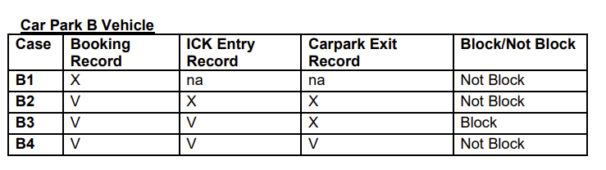

If LPNs is not in block list, open Gate Barrier and Create Parking Record.

## API Integration Flow

### CPVACS ICK to G/F Entry

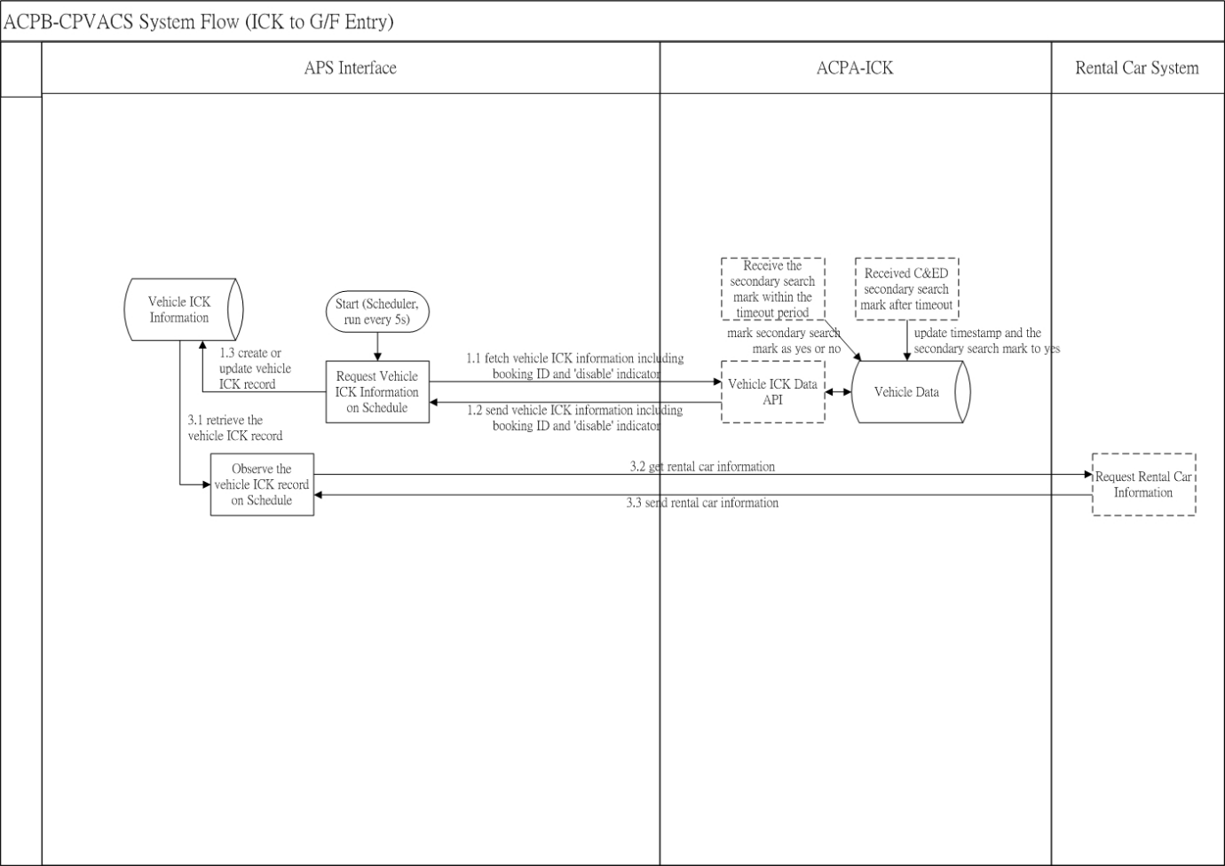

### CPVACS G/F Entry

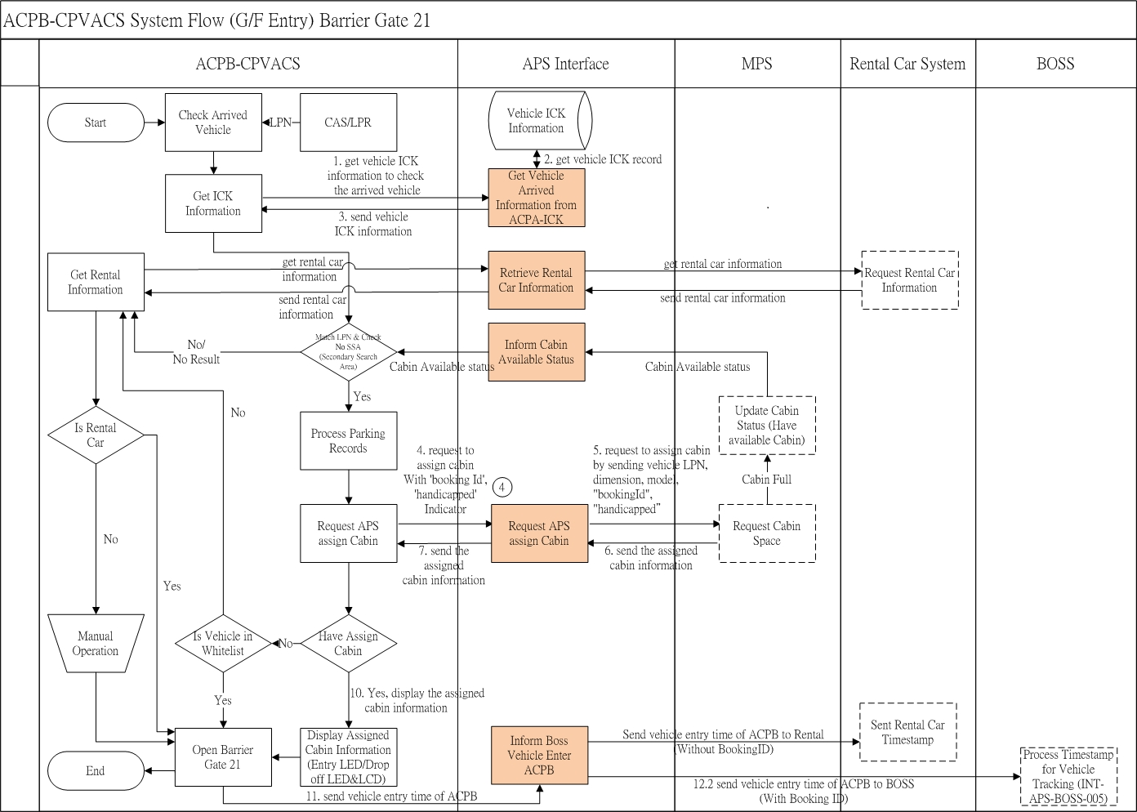

### CPVACS G/F Cabin Drop Off Area

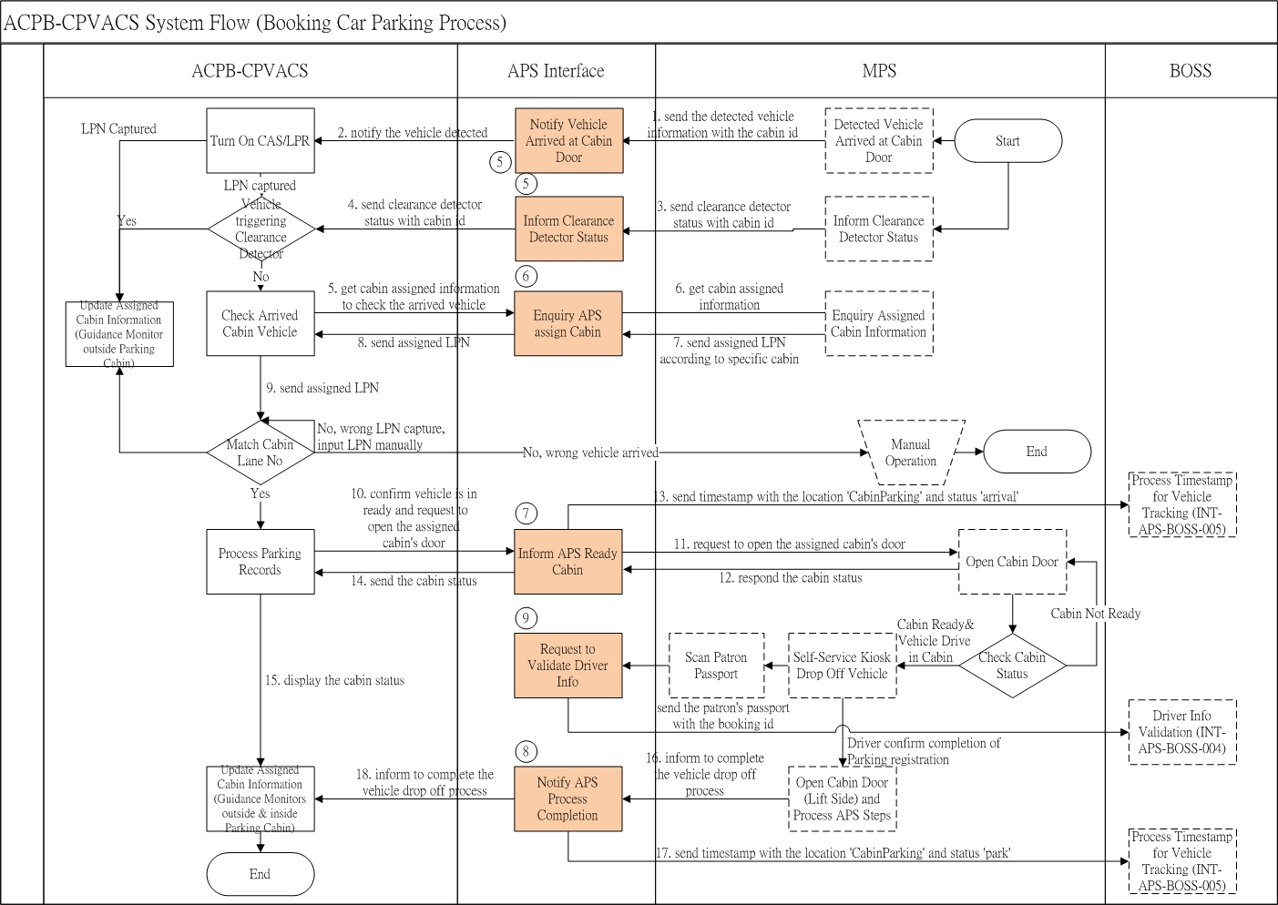

### CPVACS Cabin Pick Up Area

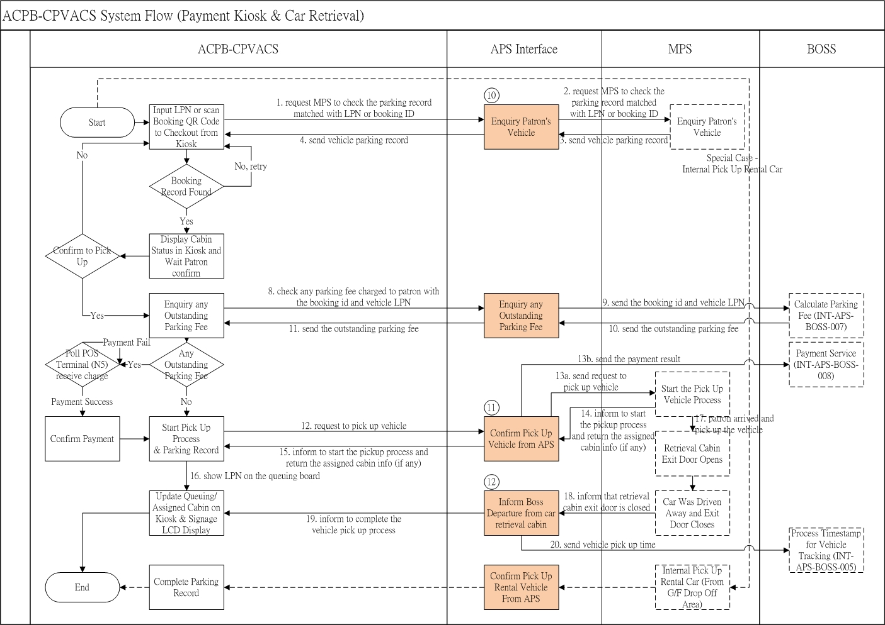

### CPVACS G/F, M/F Exit Gate and M/F Exit Gate in Rental Car Pick Up Area

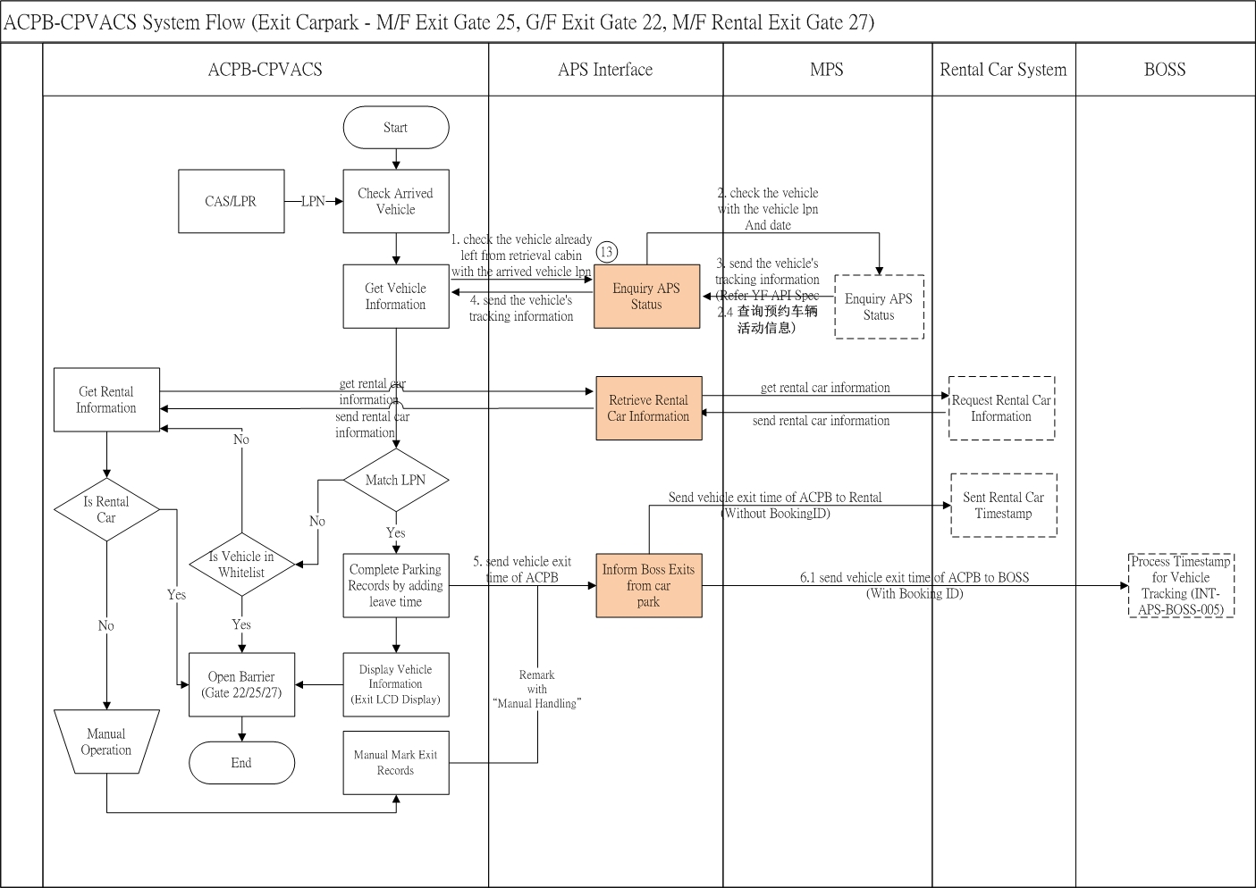

### CPVACS Cabin Other Cases

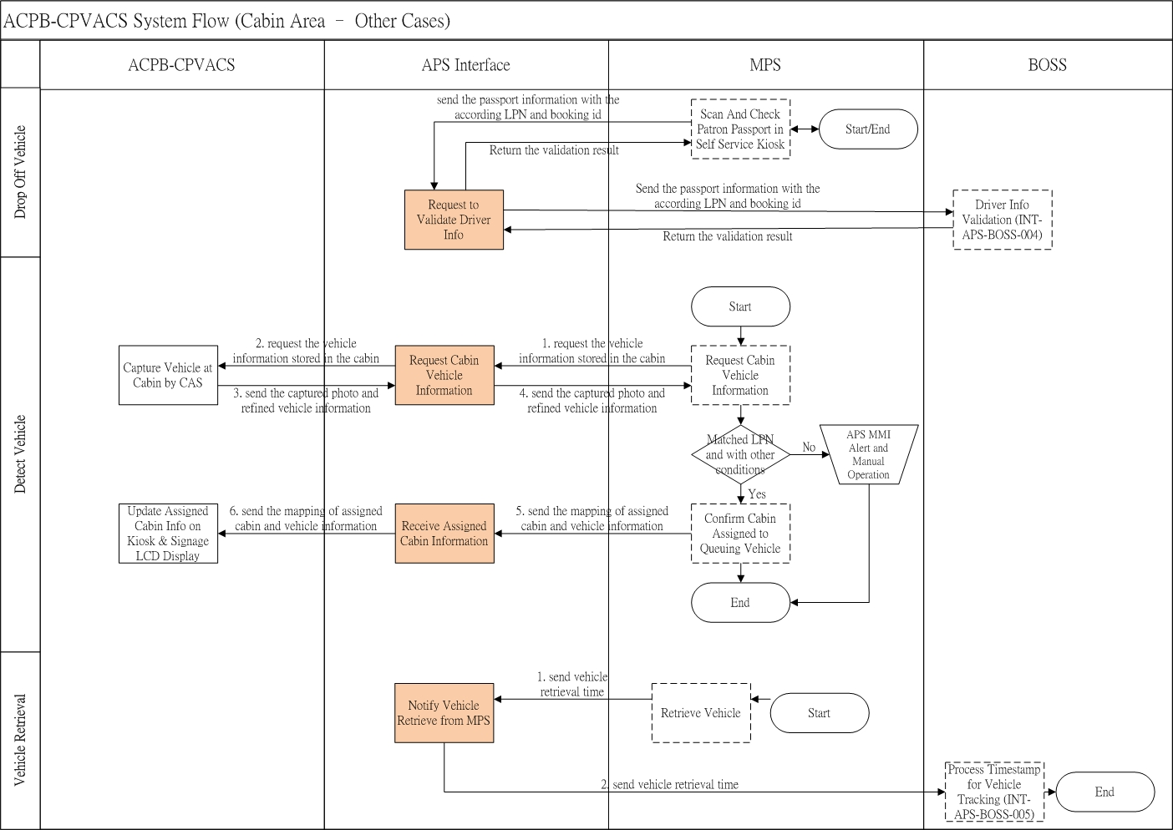

### CPVACS G/F Exit in Rental Car Drop Off Area

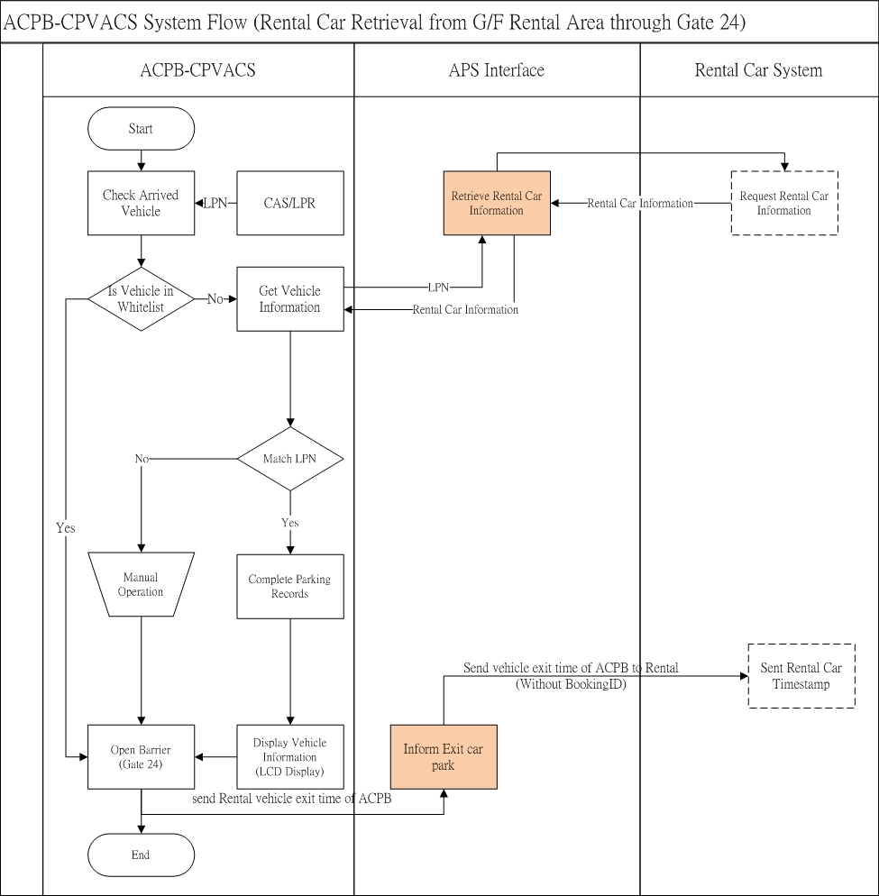

### CPVACS G/F Entry in Rental Car Drop Off Area

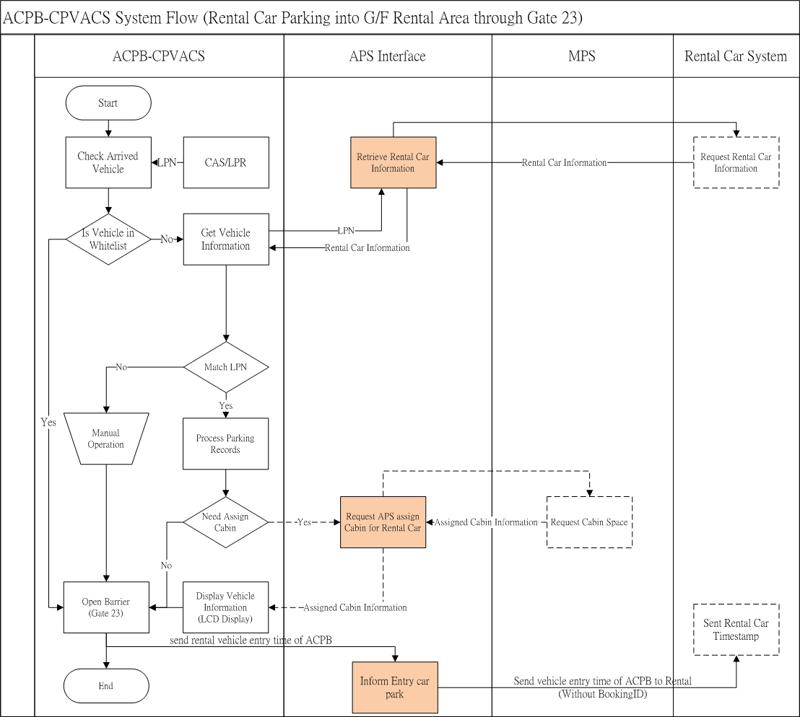

### CPVACS M/F Entry in Rental Car Pick Up Area

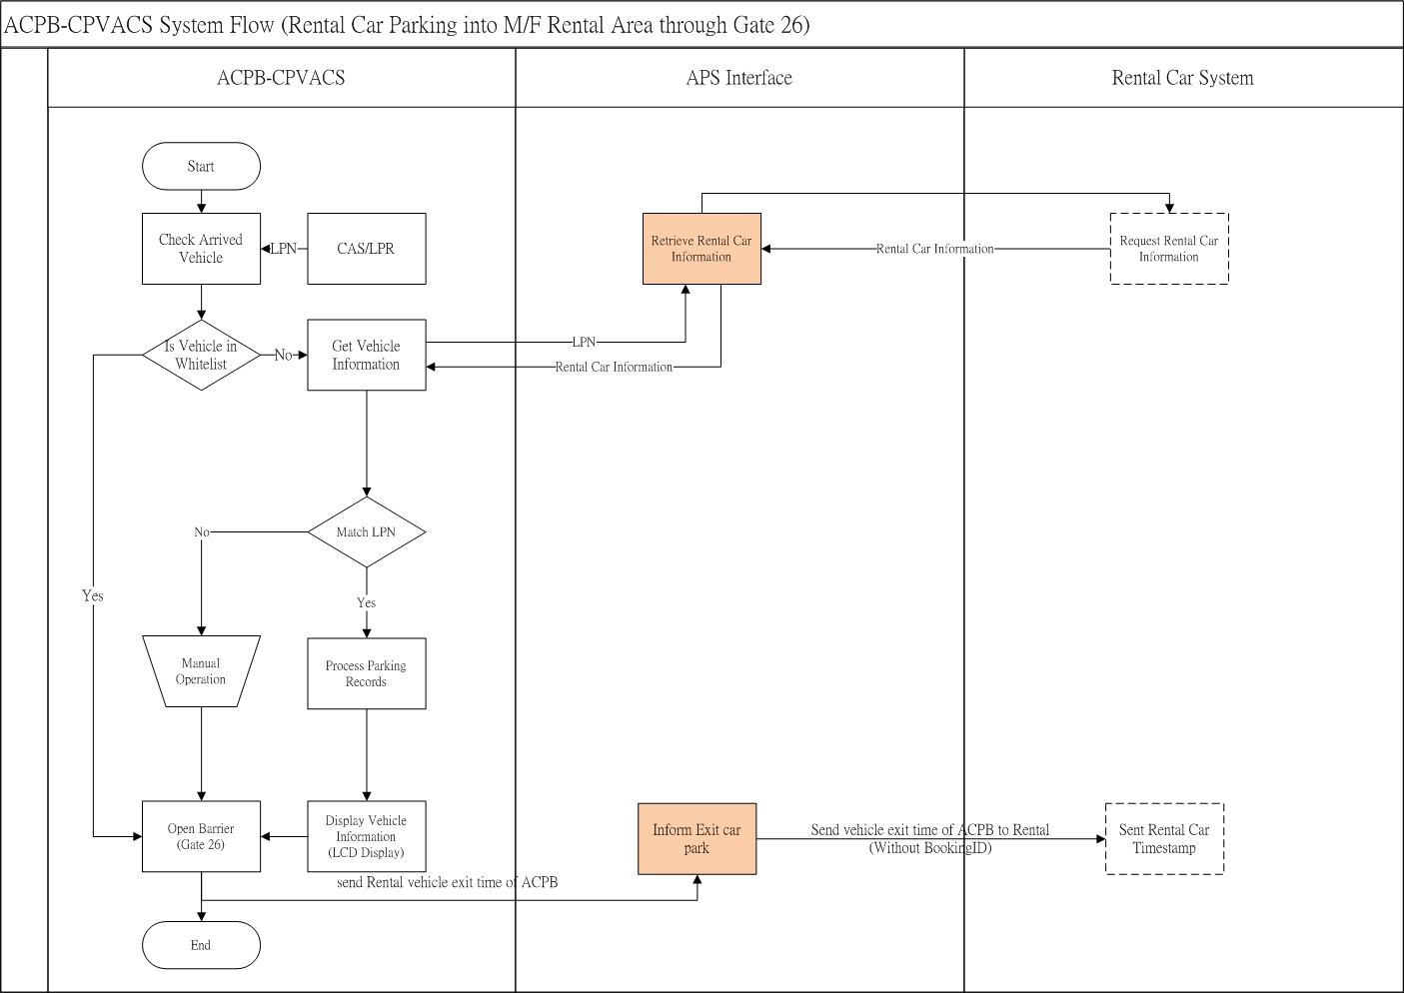

### MPS and BOSS Booking Information

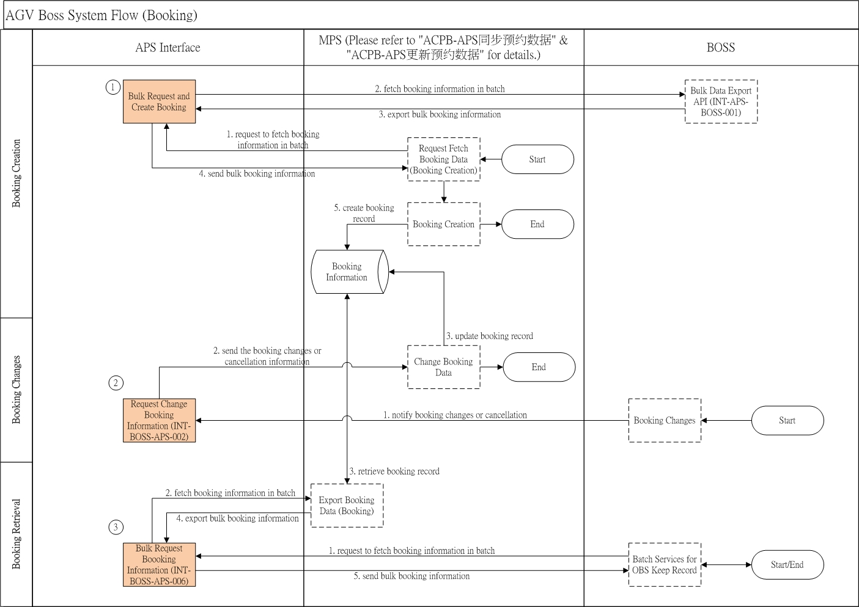

### CPVACS inform Device Alert to APS

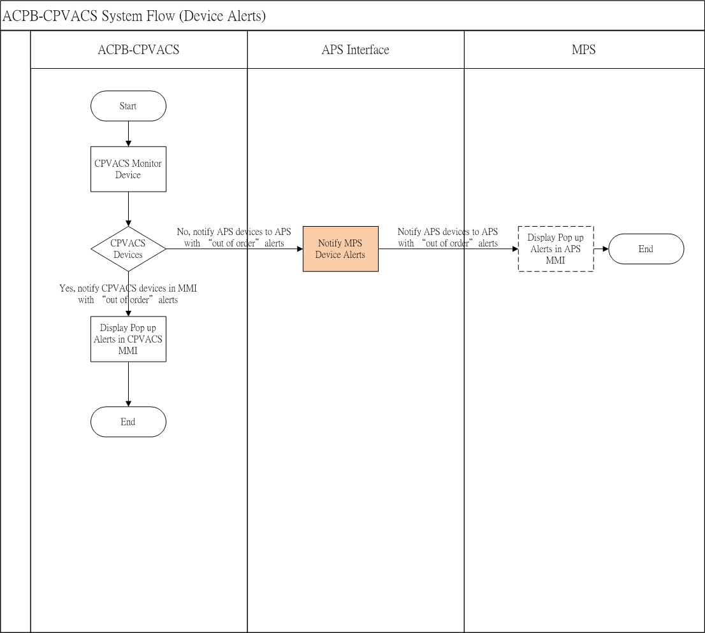

### CPVACS Shun Hang Road Access Control

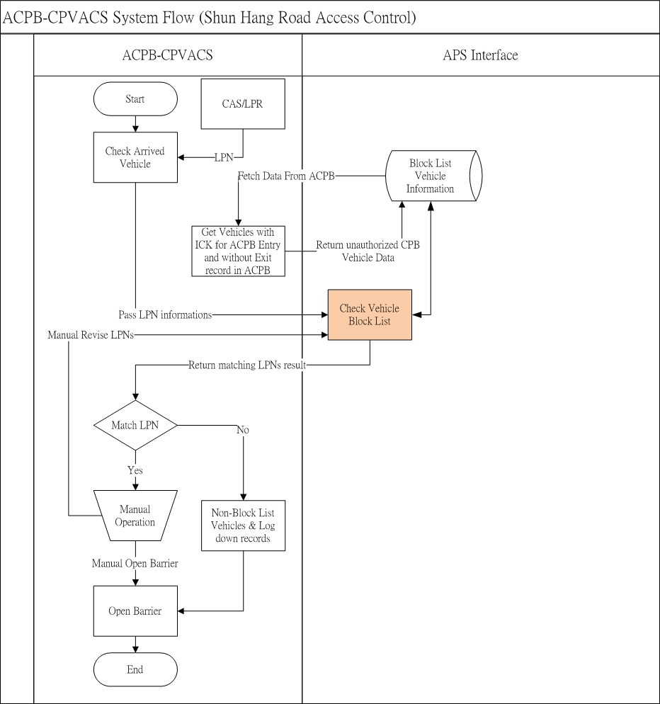

## API Specifications

### Grant JWT Token

Path:/api/cps/grantToken

Method: Post

Content-Type: JSON

Input parameter

|  |  |  |
| --- | --- | --- |
| **Field** | **Type** | **Description** |
| Username | String | User name |
| Password | Strng | Password |

Response

Status code: 200

|  |  |  |
| --- | --- | --- |
| **Field** | **Type** | **Description** |
| accessToken | String | Sample:  eyJhbGciOiJIUzI1NiIsInR5cCI6IkpXVCJ9.eyJqdGkiOiI5ZDdmZWZjYy0wYTFkLTQyNTAtYjRmNS04Mm |
| expiresIn | Timespan | Expired Time |

### Refresh JWT Token

Path:/api/cps/refreshToken

Method: Get

Content-Type: JSON

Authorization: Bearer

Input parameter

N.A.

Response

Status code: 200

|  |  |  |
| --- | --- | --- |
| **Field** | **Type** | **Description** |
| accessToken | String | Sample:  eyJhbGciOiJIUzI1NiIsInR5cCI6IkpXVCJ9.eyJqdGkiOiI5ZDdmZWZjYy0wYTFkLTQyNTAtYjRmNS04Mm |
| expiresIn | Timespan | Expired Time |

### CPVACS Enquiry CPA-ICK Information

Path: /api/aps/enquiryCpaIckInfo

Method: Post

Content-Type: JSON

Authorization: Bearer

Input parameter

|  |  |  |
| --- | --- | --- |
| **Field** | **Type** | **Description** |
| vehicleHongkong | String | HK License Plate Number |
| vehicleMainland | String | Mainland License Plate Number |
| vehicleMacao | String | Macau License Plate Number |
| enquiryDate | String | YYYY-MM-DD  Enquiry Date |

{

"vehicleHongkong":"XX9998",

"vehicleMainland":"XX9998",

"vehicleMacao":"XX9998",

“enquiryDate”:”2024-01-01”

}

Response

Status code: 200

|  |  |  |
| --- | --- | --- |
| **Field** | **Type** | **Description** |
| resultCode | Number | 0 - fail  1 – success |
| resultMessage | String | Result Message |
| sysDatetime | String | YYYY-MM-DD HH:NN:SS  System Date Time |
| ickInfo | String | JSON String store the related LPN’s ICK Information |

<ickInfo>

|  |  |  |
| --- | --- | --- |
| **Field** | **Type** | **Description** |
| vehicleHongkong | String | HK License Plate Number |
| vehicleMainland | String | Mainland License Plate Number |
| vehicleMacao | String | Macau License Plate Number |
| height | Number | Vehicle Height (mm) |
| length | Number | Vehicle Length (mm) |
| width | Number | Vehicle Width (mm) |
| secondSearchFlag | Number | Secondary Search Mark  0 = Not Required to Secondary Search  1 = Required to Secondary Search |
| secondSearchEventDate | String | YYYY-MM-DD  Date of Event |
| secondSearchEventTime | String | HH:NN:SS  Time of Event |
| clearanceFlag | Number | Clearance Flag, only require to check when secondSearchFlag = 1  1 = Not Pass  2 = Passed |
| bookingId | String | Booking ID |
| handicapped | Number | People with Disabilities  0 = No  1 = Yes |

{

"resultCode":1,

"resultMessage":“success”,

“sysDatetime”:”2024-01-01 23:00:00”,

"ickInfo":

{

"vehicleHongkong":"XX9998",

"vehicleMainland":"XX9998",

"vehicleMacao":"XX9998",

"height":2000,

"length":3000,

"width":2000,

"secondSearchFlag":0,

"secondSearchEventDate":"2024-01-01",

"secondSearchEventTime":"23:15:00",

"clearanceFlag":1,

"bookingId":”B01”,

"handicapped":0

}

}

Remarks: To check the arrived vehicle at entry gate, ACPB-CPVACS will request to get the vehicle ICK information which stored in the APS by calling ***APS API - CPVACS Enquiry CPA-ICK Information***. ACPB-CPVACS will then request the cabin assigned to vehicle which matched with ICK information, passed secondary search and clearance flag.

### CPVACS Enquiry Rental Car Information (TBC)

Path: /api/aps/enquiryRentalCarInfo

Method: Post

Content-Type: JSON

Authorization: Bearer

Input parameter

|  |  |  |
| --- | --- | --- |
| **Field** | **Type** | **Description** |
| vehicleHongkong | String | HK License Plate Number |
| vehicleMainland | String | Mainland License Plate Number |
| vehicleMacao | String | Macau License Plate Number |

{

"vehicleHongkong":"XX9998",

"vehicleMainland":"XX9998",

"vehicleMacao":"XX9998",

}

Response

Status code: 200

|  |  |  |
| --- | --- | --- |
| **Field** | **Type** | **Description** |
| resultCode | Number | 0 - fail  1 – Rented Out  2 – Not Leased  3 – Not a Rental Car |
| resultMessage | String | Result Message |
| vehicleHongkong | String | HK License Plate Number |
| vehicleMainland | String | Mainland License Plate Number |
| vehicleMacao | String | Macau License Plate Number |
| rentalId | String | Rental Record ID |
| rentalFromDatetime | String | YYYY-MM-DD HH:NN:SS  Rental From Date, Empty when result code status is not 1 |
| rentalToDatetime | String | YYYY-MM-DD HH:NN:SS  Rental To Date, Empty when result code status is not 1 |
| sysDatetime | String | YYYY-MM-DD HH:NN:SS  System Date Time |

{

"resultCode": 1,

"resultMessage": “”,

"vehicleHongkong":"XX9999",

"vehicleMainland":"XX9999",

"vehicleMacao":"XX9999",

“rentalId”:”XXXXXXX”,

“rentalFromDatetime”:” 2024-01-01 23:00:00”,

“rentalToDatetime”:” 2024-01-03 23:00:00”,

“sysDatetime”:”2024-01-01 23:00:00”

}

Remarks: Middleware will enquiry Rental Car Information provide by Rental Car System API (TBC)

### ~~CPVACS Update CPA-ICK Information (Obsoleted)~~

~~Path: /api/aps/updateCpaIckInfo~~

~~Method: Post~~

~~Content-Type: JSON~~

~~Authorization: Bearer~~

~~Input parameter~~

|  |  |  |
| --- | --- | --- |
| **~~Field~~** | **~~Type~~** | **~~Description~~** |
| ~~vehicleHongkong~~ | ~~String~~ | ~~HK License Plate Number~~ |
| ~~vehicleMainland~~ | ~~String~~ | ~~Mainland License Plate Number~~ |
| ~~vehicleMacao~~ | ~~String~~ | ~~Macau License Plate Number~~ |
| ~~height~~ | ~~Number~~ | ~~Vehicle Height (mm)~~ |
| ~~length~~ | ~~Number~~ | ~~Vehicle Length (mm)~~ |
| ~~width~~ | ~~Number~~ | ~~Vehicle Width (mm)~~ |
| ~~secondSearchFlag~~ | ~~Number~~ | ~~Secondary Search Mark~~  ~~0 = Not Required to Secondary Search~~  ~~1 = Required to Secondary Search~~ |
| ~~secondSearchEventDate~~ | ~~String~~ | ~~YYYY-MM-DD~~  ~~Date of Event~~ |
| ~~secondSearchEventTime~~ | ~~String~~ | ~~HH:NN:SS~~  ~~Time of Event~~ |

~~{~~

~~"vehicleHongkong":"XX9998",~~

~~"vehicleMainland":"XX9998",~~

~~"vehicleMacao":"XX9998",~~

~~"height":2000,~~

~~"length":3000,~~

~~"width":2000,~~

~~"secondSearchFlag":0,~~

~~"secondSearchEventDate":”2024-01-01",~~

~~"secondSearchEventTime":”23:15:00"~~

~~}~~

~~Response~~

~~Status code: 200~~

|  |  |  |
| --- | --- | --- |
| **~~Field~~** | **~~Type~~** | **~~Description~~** |
| ~~resultCode~~ | ~~Number~~ | ~~0 - fail~~  ~~1 - success~~ |
| ~~resultMessage~~ | ~~String~~ | ~~Result Message~~ |
| ~~sysDatetime~~ | ~~String~~ | ~~YYYY-MM-DD HH:NN:SS~~  ~~System Date Time~~ |

~~{~~

~~"resultCode":1,~~

~~"resultMessage":“Update ICK result success”,~~

~~“sysDatetime”:”2024-01-01 23:00:00”~~

~~}~~

~~Remarks: ICK inform ACPB-CPVACS the vehicle released from secondary search and ACPB-CPVACS will update APS the secondary search mark changed as "No" through~~ ***~~APS API - CPVACS Update CPA-ICK Information~~***~~. APS will then request MPS to pre-assign the cabin space by calling~~ ***~~MPS API - 预先分配停车入口~~*** ~~triggered by APS vehicle ICK Record Observer.~~

### CPVACS Request MPS Cabin

Path: /api/aps/requestMPSCabin

Method: Post

Content-Type: JSON

Authorization: Bearer

Input parameter

|  |  |  |
| --- | --- | --- |
| **Field** | **Type** | **Description** |
| parkId | String | Car Park ID |
| gateId | String | Gate ID |
| vehicleHongkong | String | HK License Plate Number |
| vehicleMainland | String | Mainland License Plate Number |
| vehicleMacao | String | Macau License Plate Number |
| height | Number | Vehicle Height (mm) |
| length | Number | Vehicle Length (mm) |
| width | Number | Vehicle Width (mm) |
| bookingId | String | Booking ID |
| handicapped | Number | People with Disabilities  0 = No  1 = Yes |

{

“parkId”:”P01”,

“gateId”:”G01”,

"vehicleHongkong":"XX9998",

"vehicleMainland":"XX9998",

"vehicleMacao":"XX9998",

"height":1000,

"length":2000,

"width":2000,

"bookingId":”B01”,

"handicapped":0

}

Response

Status code: 200

|  |  |  |
| --- | --- | --- |
| **Field** | **Type** | **Description** |
| resultCode | Number | 0 - fail  1 – Have Booking in BOSS  2 – No Booking |
| resultMessage | String | Result Message |
| sysDatetime | String | YYYY-MM-DD HH:NN:SS  System Date Time |
| vehicleHongkong | String | HK License Plate Number |
| vehicleMainland | String | Mainland License Plate Number |
| vehicleMacao | String | Macau License Plate Number |
| Status | Number | 1: Assign successfully  2: Wait  3: Forbidden |
| cabinId | String | Cabin ID  Empty when result code status is not 1 |
| cabinName | String | Cabin Name |
| assignedDatetime | String | YYYY-MM-DD HH:NN:SS  Cabin Assigned Date Time, Empty when result code status is not 1 |
| bookingId | String | Booking ID |
| Remark | String | Remark |

{

"resultCode": 1,

"resultMessage": “”,

“sysDatetime”:”2024-01-01 23:00:00”

"vehicleHongkong":"XX9998",

"vehicleMainland":"XX9998",

"vehicleMacao":"XX9998",

"status":1,

“cabinId”:”G1”,

"cabinName":"Gate 1",

“assignedDatetime”:”2024-01-01 23:00:00”,

"bookingId":"XX9998",

“remark”:””

}

Remarks: ACPB-CPVACS call ***MPS API - 道闸车牌识别（申请分配停车入口）*** through ***APS API - CPVACS Request MPS Cabin*** to request MPS to assign the cabin space for the vehicle which passed the checking of CPVACS. CPVACS will obtain the assigned cabin information and this information will be shown on the LCD board at ACPB entry. Patron will access the cabin information through the LCD board and drive to the right place.

### CPVACS notify Boss Vehicle Enter ACPB

Path: /api/aps/notifyBOSSEnter

Method: Post

Content-Type: JSON

Authorization: Bearer

Input parameter

|  |  |  |
| --- | --- | --- |
| **Field** | **Type** | **Description** |
| vehicleHongkong | String | HK License Plate Number |
| vehicleMainland | String | Mainland License Plate Number |
| vehicleMacao | String | Macau License Plate Number |
| entryDatetime | String | YYYY-MM-DD HH:NN:SS  ACPB Entry Date Time |
| bookingId | String | Booking ID |
| parkingRecordId | String | CPVACS Parking Record ID |
| laneCode | String | Lane Code |
| remark | String | With the value ‘Modified LPN’ if LPN was modified |

{

"vehicleHongkong":"XX9998",

"vehicleMainland":"XX9998",

"vehicleMacao":"XX9998",

“entryTime”:”2024-01-01 23:00:00”,

“bookingId”:”XXXX01”,

“parkingRecordId”:”PR00001”,

“laneCode”:”entrance”,

“remark”:””

}

Response

Status code: 200

|  |  |  |
| --- | --- | --- |
| **Field** | **Type** | **Description** |
| resultCode | Number | 0 - fail  1 – success |
| resultMessage | String | Result Message |
| sysDatetime | String | YYYY-MM-DD HH:NN:SS  System Date Time |

{

"resultCode": 1,

"resultMessage": “”,

“sysDatetime”:”2024-01-01 23:00:00”,

}

Remarks: ACPB-CPVACS call ***BOSS API - INT-APS-BOSS-005*** through ***APS API - CPVACS notify Boss Vehicle Enter ACPB*** to inform BOSS the vehicle has been entered into car park b. BOSS will receive the vehicle entry time of car park b.

### MPS Notify CPVACS Vehicle Arrived at Drop Off Cabin Door

Path: /api/aps/notifyCPVACSVehicleArrivedCabinDoor

Method: Post

Content-Type: JSON

Authorization: Bearer

Input parameter

|  |  |  |
| --- | --- | --- |
| **Field** | **Type** | **Description** |
| cabinId | String | Cabin ID |
| loop | Number | Loop Status  0 - fail  1 - success |
| vehicleBottomHeight | Number | Height from floor to bottom of vehicle  0 - standard  1 - middle  2 - full |
| vehicleStatus | Number | Parking Status of Vehicle  0 - abnormal  1 - normal |
| arriveCabinDoorDatetime | String | YYYY-MM-DD HH:NN:SS  Time Arrived at Cabin Door |

{

"cabinId":"C01",

"loop":1,

"vehicleBottomHeight ":1,

"vehicleStatus":1,

"arriveCabinDoorDatetime":”2024-01-01 23:00:00”

}

Response

Status code: 200

|  |  |  |
| --- | --- | --- |
| **Field** | **Type** | **Description** |
| resultCode | Number | 0 - fail  1 - success |
| resultMessage | String | Result Message |
| sysDatetime | String | YYYY-MM-DD HH:NN:SS  System Date Time |

{

"resultCode": 1,

"resultMessage": “”,

“sysDatetime”:”2024-01-01 23:00:00”

}

Remarks: MPS call ACPB-CPVACS's API through ***APS API - MPS Notify CPVACS Vehicle Arrived at Drop Off Cabin Door*** to inform ACPB-CPVACS the vehicle has been arrived at transfer cabin door with providing the detected vehicle information. ACPB-CPVACS will turn on the CAS/LPR to capture the LPN of arrived vehicle.

### CPVACS Send MPS Arrived Cabin Vehicle Information

Path: /api/aps/sendMPSArrivedCabinVehicleInfo

Method: Post

Content-Type: JSON

Authorization: Bearer

Input parameter

|  |  |  |
| --- | --- | --- |
| **Field** | **Type** | **Description** |
| cabinId | String | Cabin ID |
| vehicleHongkong | String | HK License Plate Number |
| vehicleMainland | String | Mainland License Plate Number |
| vehicleMacao | String | Macau License Plate Number |
| lpnCaptureDatetime | String | YYYY-MM-DD HH:NN:SS  Datetime of LPN captured by CPVACS |

{

"cabinId":"C01",

"vehicleHongkong":"XX9998",

"vehicleMainland":"XX9998",

"vehicleMacao":"XX9998"

"lpnCaptureDatetime":”2024-01-01 23:00:00”

}

Response

Status code: 200

|  |  |  |
| --- | --- | --- |
| **Field** | **Type** | **Description** |
| resultCode | Number | 0 - fail  1 - success |
| resultMessage | String | Result Message |
| sysDatetime | String | YYYY-MM-DD HH:NN:SS  System Date Time |

{

"resultCode": 1,

"resultMessage": “”,

“sysDatetime”:”2024-01-01 23:00:00”

}

Remarks: After vehicle arrived at transfer cabin door and capturing the LPN, ACPB-CPVACS will call ***MPS API - 大昌APS接口提供到达停车入口车辆信息*** through ***APS API - CPVACS Send MPS Arrived Cabin Vehicle Information*** to send the LPN to MPS. MPS will display LPN for specific transfer cabin on MPS's MMI.

### CPVACS Enquiry MPS Cabin Status

Path: /api/aps/enquiryMPSCabinStatus

Method: Post

Content-Type: JSON

Authorization: Bearer

Input parameter

|  |  |  |
| --- | --- | --- |
| **Field** | **Type** | **Description** |
| cabinId | String | Cabin ID |

{

"cabinId":"G1"

}

Response

Status code: 200

|  |  |  |
| --- | --- | --- |
| **Field** | **Type** | **Description** |
| resultCode | Number | 0 - fail  1 - Assigned  2 – Not Yet assigned |
| resultMessage | String | Result Message |
| cabinId | String | Cabin ID |
| assignedVehicleHongkong | String | Assigned HK License Plate Number |
| assignedVehicleMainland | String | Assigned Mainland License Plate Number |
| assignedVehicleMacao | String | Assigned Macau License Plate Number |
| assignedDatetime | String | YYYY-MM-DD HH:NN:SS  Assigned Date Time, Empty when result code is not 1 |
| bookingId | String | Booking ID |
| sysDatetime | String | YYYY-MM-DD HH:NN:SS  System Date Time |

{

"resultCode": 1,

"resultMessage": “”,

“cabinId”:”G1”,

"assingedVehicleHongkong":"XX9998",

"assingedVehicleMainland":"XX9998",

"assingedVehicleMacao":"XX9998",

“assignedDatetime”:”2024-01-01 23:00:00”,

"bookingId":"B01",

“sysDatetime”:”2024-01-01 23:00:00”

}

Remarks: To check the arrived vehicle at transfer cabin door, ACPB-CPVACS will call ***MPS API - 查询入口状态*** through ***APS API - CPVACS Enquiry MPS Cabin Status*** to request to get the cabin assigned information from MPS. APS will get and return the specific cabin assigned information to the ACPB-CPVACS.

### CPVACS Inform MPS Ready Cabin

Path: /api/aps/informMPSCabinReady

Method: Post

Content-Type: JSON

Authorization: Bearer

Input parameter

|  |  |  |
| --- | --- | --- |
| **Field** | **Type** | **Description** |
| cabinId | String | Cabin ID |
| vehicleHongkong | String | HK License Plate Number |
| vehicleMainland | String | Mainland License Plate Number |
| vehicleMacao | String | Macau License Plate Number |
| bookingId | String | Booking ID |
| parkingRecordId | String | CPVACS Parking Record ID |
| parkInDatetime | String | YYYY-MM-DD HH:NN:SS  Parking In Date Time |
| remark | String | With the value ‘Modified LPN’ if LPN was modified |

{

"cabinId":"G1",

"vehicleHongkong":"XX9998",

"vehicleMainland":"XX9998",

"vehicleMacao":"XX9998",

“bookingId”:”B01”,

“parkingRecordId”:”99999999999999999999”,

“parkinDatetime”:”2024-01-01 22:00:00”

“remark”:””

}

Response

Status code: 200

|  |  |  |
| --- | --- | --- |
| **Field** | **Type** | **Description** |
| resultCode | Number | 0 - fail  1 – ready  2 – not ready |
| resultMessage | String | Result Message |
| sysDatetime | String | YYYY-MM-DD HH:NN:SS  System Date Time |
| cabinId | String | Cabin ID |
| vehicleHongkong | String | HK License Plate Number |
| vehicleMainland | String | Mainland License Plate Number |
| vehicleMacao | String | Macau License Plate Number |
| bookingId | String | Booking ID |
| parkingRecordId | String | CPVACS Parking Record ID |

{

"resultCode": 1,

"resultMessage": “”,

“sysDatetime”:”2024-01-01 23:00:00”

“cabinId”:”G1”,

"vehicleHongkong":"XX9998",

"vehicleMainland":"XX9998",

"vehicleMacao":"XX9998",

"bookingId":"B01”,

"parkingRecordId":"P01”

}

Remarks: After having a check on arrived vehicle at transfer cabin door, ACPB-CPVACS will call ***MPS API - 打开停车入口*** through ***APS API - CPVACS Inform MPS Ready Cabin*** for the vehicle passed checking to request MPS to open the assigned cabin's door. MPS will return the cabin status to the ACPB-CPVACS and ACPB-CPVACS will display the cabin information on the LCD display at the transfer cabin door. Patron will access the cabin information through the LCD display for their next step.

### MPS Notify CPVACS/BOSS MPS Drop Off Complete

Path: /api/aps/notifyDropOffComplete

Method: Post

Content-Type: JSON

Authorization: Bearer

Input parameter

|  |  |  |
| --- | --- | --- |
| **Field** | **Type** | **Description** |
| cabinId | String | Cabin ID |
| bookingId | String | Booking ID |
| parkingRecordId | String | CPVACS Parking Record ID |
| vehicleHongkong | String | HK License Plate Number |
| vehicleMainland | String | Mainland License Plate Number |
| vehicleMacao | String | Macau License Plate Number |
| completeDropOffTime | String | YYYY-MM-DD HH:NN:SS  MPS Drop Off completion Date Time |
| remark | String | Text field for inputing remark for the special scenarios |

{

“cabinId”:”G1”,

"bookingId":"XX9998",

“parkingRecordId”:”99999999999999999999”,

"vehicleHongkong":"XX9998",

"vehicleMainland":"XX9998",

"vehicleMacao":"XX9998",

“completeDropOffTime”:”2024-01-01 22:00:00”,

"remark":"collection of items left behind after vehicle is parked into APS"

}

Response

Status code: 200

|  |  |  |
| --- | --- | --- |
| **Field** | **Type** | **Description** |
| resultCode | Number | 0 - fail  1 – success |
| resultMessage | String | Result Message |
| sysDatetime | String | YYYY-MM-DD HH:NN:SS  System Date Time |

{

"resultCode": 1,

"resultMessage": “”,

“sysDatetime”:”2024-01-01 23:00:00”

}

Remarks: After cabin door(storage side) opens, MPS will call both ACPB-CPVACS's API and ***BOSS API - INT-APS-BOSS-005*** through ***APS API - MPS Notify CPVACS/BOSS MPS Drop Off Complete*** to inform ACPB-CPVACS and BOSS the process has been completed. ACPB-CPVACS will update LCD display at the transfer cabin door. BOSS will receive the vehicle drop off time of transfer cabin.

### CPVACS Enquiry MPS Vehicle Status

Path: /api/aps/enquiryVehicleStatus

Method: Post

Content-Type: JSON

Authorization: Bearer

Input parameter

|  |  |  |
| --- | --- | --- |
| **Field** | **Type** | **Description** |
| vehicleHongkong | String | HK License Plate Number |
| vehicleMainland | String | Mainland License Plate Number |
| vehicleMacao | String | Macau License Plate Number |
| bookingId | String | Booking ID |

{

"vehicleHongkong":"XX9998",

"vehicleMainland":"XX9998",

"vehicleMacao":"XX9998",

"bookingId":"B01”

}

Response

Status code: 200

|  |  |  |
| --- | --- | --- |
| **Field** | **Type** | **Description** |
| resultCode | Number | 0 - fail  1 – parking  2 – not parking  3–parking but license plate number and driver facial information does not match |
| resultMessage | String | Result Message |
| sysDatetime | String | YYYY-MM-DD HH:NN:SS  System Date Time |
| vehicleHongkong | String | HK License Plate Number |
| vehicleMainland | String | Mainland License Plate Number |
| vehicleMacao | String | Macau License Plate Number |
| cabinId | String | Cabin ID  If Vehicle is not yet confirmed pick up, Cabin ID will be empty |
| mpsRecordId | String | MPS Record ID |
| warehouseId | String | Warehouse ID |
| areaId | String | Area ID |
| vehicleImgUrl | String | Vehicle Image URL |
| vehicleImg | String | Vehicle Image in Base64 |
| parkingRecordId | String | CPVACS Parking Record ID |
| parkInDatetime | String | YYYY-MM-DD HH:NN:SS  Parking In Date Time |
| remark | String | Remarks |
| bookingId | String | Booking ID |
| parkingFrom | String | YYYY-MM-DD HH:NN:SS  Booking From Time |
| parkingTo | String | YYYY-MM-DD HH:NN:SS  Booking To Time |

{

"resultCode": 1,

"resultMessage": “”,

“sysDatetime”:”2024-01-01 23:00:00”,

"vehicleHongkong":"XX9998",

"vehicleMainland":"XX9998",

"vehicleMacao":"XX9998",

"cabinId": “”,

"mpsRecordId": “XXX”,

"warehouseId": “XXX”,

"areId": “XXX”,

"vehicleImgUrl": “http://XXXXXX/XXX.JPG”,

"vehicleImg": “XXXXXXXXXXXXXXXXXXXXXXXXXXX”,

"parkingRecordId": “PR00001”,

"parkInDateTime": “2024-01-01 10:00:00”,

“remark": “XXXXXXXXXXXX”,

“bookingId":"XX9998",

“parkingFrom":"2024-01-01 09:45:00",

“parkingTo":"2024-01-01 21:00:00"

}

Remarks: Patron arrived at Kiosk to start the checkout process. After patron input LPN from Kiosk, ACPB-CPVACS will call ***MPS API - 查询库内车辆信息*** through ***APS API - CPVACS Enquiry MPS Vehicle Status*** to request MPS to check the parking record which matched with input LPN. APS will get and return the according vehicle parking record to ACPB-CPVACS. If the matching parking record is found, ACPB-CPVACS will then request the patron to scan the booking QR code and passport.

### CPVACS Enquiry Vehicle Outstanding Parking Fee

Path: /api/aps/enquiryParkingFee

Method: Post

Content-Type: JSON

Authorization: Bearer

Input parameter

|  |  |  |
| --- | --- | --- |
| **Field** | **Type** | **Description** |
| bookingId | String | Booking ID |
| vehicleHongkong | String | HK License Plate Number |
| vehicleMainland | String | Mainland License Plate Number |
| vehicleMacao | String | Macau License Plate Number |
| checkoutDatetime | String | YYYY-MM-DD HH:NN:SS  Check out Date Time |

{

"bookingId":"XXXX01",

"vehicleHongkong":"XX9998",

"vehicleMainland":"XX9998",

"vehicleMacao":"XX9998",

"checkoutDatetime":"2024-01-01 23:00:00"

}

Response

Status code: 200

|  |  |  |
| --- | --- | --- |
| **Field** | **Type** | **Description** |
| resultCode | Number | 0 - fail  1 – success |
| resultMessage | String | Result Message |
| sysDatetime | String | YYYY-MM-DD HH:NN:SS  System Date Time |
| oustandingBalance | Double | Outstanding Parking Fee in HKD |

{

"resultCode": 1,

"resultMessage": “”,

“sysDatetime”:”2024-01-01 23:00:00”,

"oustandingBalance": 300.00

}

Remarks: After patron confirmed to pick up the vehicle, ACPB-CPVACS will call ***BOSS API - INT-APS-BOSS-007*** through ***APS API - CPVACS Enquiry Vehicle Outstanding Parking Fee*** to check with BOSS any outstanding parking fee of the patron's booking. APS will get and return the outstanding parking fee to the ACPB-CPVACS. ACPB-CPVACS will display the outstanding parking fee on the Kiosk if any outstanding parking fee required to settle.

### CPVACS Confirm MPS Pick Up Vehicle

Path: /api/aps/confirmPickUpVehicle

Method: Post

Content-Type: JSON

Authorization: Bearer

Input parameter

|  |  |  |
| --- | --- | --- |
| **Field** | **Type** | **Description** |
| vehicleHongkong | String | HK License Plate Number |
| vehicleMainland | String | Mainland License Plate Number |
| vehicleMacao | String | Macau License Plate Number |
| confirmPickupDatetime | String | YYYY-MM-DD HH:NN:SS  Confirm Pick Up Date Time |
| bookingId | String | Booking ID |
| parkingRecordId | String | CPVACS Parking Record ID |
| mpsRecordId | String | MPS Record ID |
| remark | String | Remark |
| amount | Double | Payment amount |
| paymentStatus | Number | Payment status  0 - fail  1 - success |

{

"vehicleHongkong":"XX9998",

"vehicleMainland":"XX9998",

"vehicleMacao":"XX9998",

"confirmPickupDatetime":"2024-01-01 23:00:00",

“bookingId”:”XXXX01”,

“parkingRecordId”:”P01”,

“mpsRecordId”:”M01”,

“remark”:”XXXX”,

“amount”:”50.10”,

“paymentStatus”:1,

}

Response

Status code: 200

|  |  |  |
| --- | --- | --- |
| **Field** | **Type** | **Description** |
| resultCode | Number | 0 - fail  1 – success |
| resultMessage | String | Result Message |
| sysDatetime | String | YYYY-MM-DD HH:NN:SS  System Date Time |
| vehicleHongkong | String | HK License Plate Number |
| vehicleMainland | String | Mainland License Plate Number |
| vehicleMacao | String | Macau License Plate Number |
| cabinId | String | Cabin ID |
| mpsRecordId | String | MPS Record ID |
| warehouseId | String | Warehouse ID |
| areaId | String | Area ID |
| vehicleImgUrl | String | Vehicle Image URL |
| vehicleImg | String | Vehicle Image in Base64 |
| parkingRecordId | String | CPVACS Parking Record ID |
| parkInDatetime | String | YYYY-MM-DD HH:NN:SS  Parking In Date Time |
| vehicleStatus | Number | 0 - unknown  1 – not assigned  2 – cabin assigned but not arrive yet  3 - arrived |
| remark | String | Remarks |
| bookingId | String | Booking ID |

{

"resultCode": 1,

"resultMessage": “”,

“sysDatetime”:”2024-01-01 23:00:00”,

"vehicleHongkong":"XX9998",

"vehicleMainland":"XX9998",

"vehicleMacao":"XX9998",

"cabinId": “B1”,

"mpsRecordId": “XXX”,

"warehouseId": “XXX”,

"areaId": “XXX”,

"vehicleImgUrl": “http://XXXXXX/XXX.JPG”,

"vehicleImg": “XXXXXXXXXXXXXXXXXXXXXXXXXXX”,

“parkingRecordId”:”PR00001”,

“parkInDatetime”:”2024-01-01 22:00:00”,

“remark": “XXXXXXXXXXXX”

"bookingId": “B000001”

}

Remarks: After patron confirmed pick up the vehicle and settled the payment (if any), ACPB-CPVACS will call ***MPS API - 支付成功后下发取车*** and ***BOSS API - INT-APS-BOSS-008*** through ***APS API - CPVACS Confirm MPS Pick Up Vehicle*** to confirm with MPS to pick up the vehicle and update BOSS the payment result. Then, MPS will start the pickup process and find the vehicle from the warehouse. MPS may return the assigned cabin information to ACPB-CPVACS. Also, ACPB-CPVACS will display the LPN to the queuing board after receiving the return message from MPS.

### MPS Notify CPVACS/BOSS MPS Pick Up Complete

Path: /api/aps/notifyPickUpComplete

Method: Post

Content-Type: JSON

Authorization: Bearer

Input parameter

|  |  |  |
| --- | --- | --- |
| **Field** | **Type** | **Description** |
| cabinId | String | Cabin ID |
| bookingId | String | Booking ID |
| parkingRecordId | String | CPVACS Parking Record ID |
| mpsRecordId | String | MPS Record ID |
| vehicleHongkong | String | HK License Plate Number |
| vehicleMainland | String | Mainland License Plate Number |
| vehicleMacao | String | Macau License Plate Number |
| completePickUpTime | String | YYYY-MM-DD HH:NN:SS  MPS Pick Up completion Date Time |
| remark | String | Text field for inputing remark for the special scenarios |

{

“cabinId”:”C01”,

"bookingId":"B01",

“parkingRecordId”:”P01”,

"mpsRecordId":"M01",

"vehicleHongkong":"XX9998",

"vehicleMainland":"XX9998",

"vehicleMacao":"XX9998",

“completePickUpTime”:”2024-01-01 22:00:00”,

"remark":""

}

Response

Status code: 200

|  |  |  |
| --- | --- | --- |
| **Field** | **Type** | **Description** |
| resultCode | Number | 0 - fail  1 – success |
| resultMessage | String | Result Message |
| sysDatetime | String | YYYY-MM-DD HH:NN:SS  System Date Time |

{

"resultCode": 1,

"resultMessage": “”,

“sysDatetime”:”2024-01-01 23:00:00”

}

Remarks: After retrieval cabin door opens, MPS will call both ACPB-CPVACS's API and ***BOSS API - INT-APS-BOSS-00***5 through ***APS API - MPS Notify CPVACS/BOSS MPS Pick Up Complete*** to inform ACPB-CPVACS and BOSS the process has been completed. ACPB-CPVACS will update Kiosk and LCD display at the pick up cabin area. BOSS receive the vehicle pick up time of transfer cabin.

### MPS Notify ACPB pick up Rental Vehicle from MPS (Optional)

Path: /api/aps/notifyPickUp

Method: Post

Content-Type: JSON

Authorization: Bearer

Input parameter

|  |  |  |
| --- | --- | --- |
| **Field** | **Type** | **Description** |
| vehicleHongkong | String | HK License Plate Number |
| vehicleMainland | String | Mainland License Plate Number |
| vehicleMacao | String | Macau License Plate Number |
| pickUpDatetime | String | YYYY-MM-DD HH:NN:SS  Pick Up Date Time |

{

"lpn":"XX9999",

"pickUpDatetime":" 2024-01-01 23:00:00",

}

Response

Status code: 200

|  |  |  |
| --- | --- | --- |
| **Field** | **Type** | **Description** |
| resultCode | Number | 0 - fail  1 – success |
| resultMessage | String | Result Message |
| sysDatetime | String | YYYY-MM-DD HH:NN:SS  System Date Time |

{

"resultCode": 1,

"resultMessage": “”,

“sysDatetime”:”2024-01-01 23:00:00”

}

**Remarks: Middleware notify ACPB pick up Rental Vehicle by CPVACS API.**

### CPVACS notify Boss Vehicle Exit ACPB

Path: /api/aps/notifyBOSSExit

Method: Post

Content-Type: JSON

Authorization: Bearer

Input parameter

|  |  |  |
| --- | --- | --- |
| **Field** | **Type** | **Description** |
| vehicleHongkong | String | HK License Plate Number |
| vehicleMainland | String | Mainland License Plate Number |
| vehicleMacao | String | Macau License Plate Number |
| exitDatetime | String | YYYY-MM-DD HH:NN:SS  Exit Date Time |
| bookingId | String | Booking ID |
| parkingRecordId | String | CPVACS Parking Record ID |
| laneCode | String | Lane Code |
| remark | String | With the value ‘Modified LPN’ if LPN was modified |

{

"vehicleHongkong":"XX9998",

"vehicleMainland":"XX9998",

"vehicleMacao":"XX9998",

“exitDatetime”:”2024-01-01 23:00:00”,

“bookingId”:”XXXX01”,

“parkingRecordId”:”PR00001”,

“laneCode”:”exit_1”,

“remark”:””,

}

Response

Status code: 200

|  |  |  |
| --- | --- | --- |
| **Field** | **Type** | **Description** |
| resultCode | Number | 0 - fail  1 – success |
| resultMessage | String | Result Message |
| sysDatetime | String | YYYY-MM-DD HH:NN:SS  System Date Time |

{

"resultCode": 1,

"resultMessage": “”,

“sysDatetime”:”2024-01-01 23:00:00”

}

Remarks: ACPB-CPVACS call ***BOSS API - INT-APS-BOSS-005*** through ***APS API - CPVACS notify Boss Vehicle Exit ACPB*** to inform BOSS the vehicle has been exited from car park b. BOSS receive the vehicle exit time of car park b.

### MPS Create Booking Information

Path: /api/aps/fetchCreateBOSSBooking

Method: Post

Content-Type: JSON

Authorization: Bearer

Input parameter

|  |  |  |
| --- | --- | --- |
| **Field** | **Type** | **Description** |
| date | String | YYYY-MM-DD  Fetch BOSS new Booking Date |
| offset | Number | 0 as initial Value |
| batchCount | Number | Batch request Count |

{

"date":"2024-01-01",

"offset":0,

"batchCount":10

}

Response

Status code: 200

|  |  |  |
| --- | --- | --- |
| **Field** | **Type** | **Description** |
| resultCode | Number | 0 - fail  1 – success |
| resultMessage | String | Result Message |
| sysDatetime | String | YYYY-MM-DD HH:NN:SS  System Date Time |
| totalCount | Number | Total number of booking record |
| bookingInfo | String | JSON String store the related BOSS Booking Information |

<bookingInfo>

|  |  |  |
| --- | --- | --- |
| **Field** | **Type** | **Description** |
| vehicleHongkong | String | HK License Plate Number |
| vehicleMainland | String | Mainland License Plate Number |
| vehicleMacao | String | Macau License Plate Number |
| vehicleType | String | Vehicle Type |
| bookingId | String | Booking ID |
| bookingType | String | Booking Type |
| parkingFrom | String | YYYY-MM-DD HH:NN:SS  Booking From Time |
| parkingTo | String | YYYY-MM-DD HH:NN:SS  Booking To Time |
| lastModifiedTime | String | YYYY-MM-DD HH:NN:SS  Last Modified Date Time |
| bookingStatus | String | Booking Status  CONFIRM – confirm booking  CANCEL – cancel booking |

{

"resultCode":1,

"resultMessage":“”,

“sysDatetime”:”2024-01-01 23:00:00”,

“totalCount”:2,

“bookingInfo": [

{

"vehicleHongkong":"XX9999",

"vehicleMainland":"XX9999",

"vehicleMacao":"XX9999",

"vehicleType":"L1",

"bookingId":"XX9998",

"bookingType":"XX",

"parkingFrom":"2024-01-01 22:00:00",

"parkingTo":"2024-01-02 22:00:00",

"lastModifiedTime":"2024-01-01 22:00:00",

"bookingStatus":"CONFIRM"

},

{

"vehicleHongkong":"XX9998",

"vehicleMainland":"XX9998",

"vehicleMacao":"XX9998",

"vehicleType":"L1",

"bookingId":"XX9999",

"bookingType":"XX",

"parkingFrom":"2024-01-01 22:00:00",

"parkingTo":"2024-01-02 22:00:00",

"lastModifiedTime":"2024-01-01 22:00:00",

"bookingStatus":"CONFIRM"

}

]

}

Remarks: MPS schedule to fetch the booking information in batch from BOSS for ACPB use in different scenarios. MPS will call ***BOSS API - INT-APS-BOSS-001*** through ***APS API - MPS Create Booking Information*** to get and create booking record stored in MPS data storage.

### CPVACS/BOSS Enquiry Vehicle Tracking Information

Path: /api/aps/bulkExportBooking

Method: Post

Content-Type: JSON

Authorization: Bearer

Input parameter

|  |  |  |
| --- | --- | --- |
| **Field** | **Type** | **Description** |
| date | String | YYYY-MM-DD  Fetch BOSS new Booking Date |
| offset | Number | 0 as initial Value |
| batchCount | Number | Batch request Count |
| vehicleHongkong | String | HK License Plate Number (Optional) |
| vehicleMainland | String | Mainland License Plate Number (Optional) |
| vehicleMacao | String | Macau License Plate Number (Optional) |
| status | Number | Event status (Optional)  arrival  retrieval  pass |

{

"date":"2024/01/01",

"offset":0,

"batchCount":10,

"vehicleHongkong":"XX9999",

"vehicleMainland":"XX9999",

"vehicleMacao":"XX9999",

"status":3

}

Response

Status code: 200

|  |  |  |
| --- | --- | --- |
| **Field** | **Type** | **Description** |
| code | Number | 0 – success  10001 - failed |
| message | String | Result Message |
| data | Object |  |

<data>

|  |  |  |
| --- | --- | --- |
| **Field** | **Type** | **Description** |
| total | Number | Total number of booking record |
| events | Array Object | Array Object store the related BOSS Booking Information |

<events>

|  |  |  |
| --- | --- | --- |
| **Field** | **Type** | **Description** |
| bookingId | String | Booking ID |
| eventId | String | Event ID |
| vehicleHongkong | String | HK License Plate Number |
| vehicleMainland | String | Mainland License Plate Number |
| vehicleMacao | String | Macau License Plate Number |
| status | String | Event status  arrival (For Cabin)  retrieval (For Cabin)  park (For Cabin)  success (For BarrierGate)  fail (For BarrierGate) |
| checkpoint | String | Checkpoint values  BarrierGate  Cabin |
| location | String | Location values  MainGateEntry  MainGateExit0  MainGateExit1  MainGateExit2  CabinParking  CabinRetrieval |
| moreInfo | Object |  |
| remark | String | Remark |
| eventDate | String | YYYY/MM/DD  Check out date |
| eventTime | String | HH:mm:SS  Check out time |
| parkingRecordId | String | CPVACS Parking Record ID |
| mpsRecordId | String | MPS Record ID |
| primaryVehicleRegion | String | Used for LPN Display  cn - Mainland  hk – Hong Kong  mo – Macau  (Empty as CPVACS doesn’t stored this information) |

<moreInfo>

|  |  |  |
| --- | --- | --- |
| **Field** | **Type** | **Description** |
| cabinNo | String | Cabin No (i.e. 01-12)  Empty for Barrier Gate |
| ickNo | String | Empty for Cabin |

{

"code":0,

"message":“”,

"data":{

"total":50,

“events": [

{

"bookingId":"B01",

"eventId":"V01",

"vehicleHongkong":"XX9999",

"vehicleMainland":"XX9999",

"vehicleMacao":"XX9999",

"status":"success",

"checkpoint":"BarrierGate",

"location":"MainEntryGate",

"moreInfo":{

"cabinNo":"",

"ickNo":"ICK2023010100001"

},

“remark”:””,

"eventDate":"2024/01/01",

"eventTime":"23:00:00"

"parkingRecordId":"P01",

"mpsRecordId":"M01",

"primaryVehicleRegion":""

},

{

"bookingId":"B01",

"eventId":"V01",

"vehicleHongkong":"XX9999",

"vehicleMainland":"XX9999",

"vehicleMacao":"XX9999",

"status":"arrival",

"checkpoint":"Cabin",

"location":"CabinParking",

"moreInfo":{

"cabinNo":"C01",

"ickNo":""

},

“remark”:””,

"eventDate":"2024/01/02",

"eventTime":"10:00:00"

"parkingRecordId":"P01",

"mpsRecordId":"M01",

"primaryVehicleRegion":""

},…

]}

}

Remarks: To check the arrived vehicle at exit gate, ACPB-CPVACS will call ***MPS API - 查询预约车辆活动信息*** through ***APS API - CPVACS Enquiry Vehicle Tracking Information*** to get the vehicle tracking record from MPS. APS will get and return vehicle tracking information to ACPB-CPVACS. ACPB-CPVACS will open the barrier if the record is matched. To retrieve missing vehicle tracking data, BOSS will call ***MPS API - 查询预约车辆活动信息*** through ***APS API - CPVACS Enquiry Vehicle Tracking Information (INT-BOSS-APS-006)***.

### BOSS Request Change Booking Information

Path: /api/aps/changeBooking

Method: Post

Content-Type: JSON

Authorization: Bearer

Input parameter

|  |  |  |
| --- | --- | --- |
| **Field** | **Type** | **Description** |
| bookingId | String | Booking ID |
| status | String | Status values  add  update  cancel |
| bookingType | String | Booking Type |
| vehicleHongkong | String | HK License Plate Number |
| vehicleMainland | String | Mainland License Plate Number |
| vehicleMacao | String | Macau License Plate Number |
| vehicleType | String | Vehicle Type |
| parkingFrom | String | YYYY/MM/DD HH:mm:SS  Booking From Time |
| parkingTo | String | YYYY/MM/DD HH:mm:SS  Booking To Time |
| primaryVehicleRegion | String | Used for LPN Display  cn - Mainland  hk – Hong Kong  mo – Macau  (Skip this field as CPVACS doesn’t stored this information) |
| lastModifiedTime | String | YYYY-MM-DD HH:NN:SS  Last Modified Date Time |

{

"bookingId":"XX9998",

“status”:”update”,

"bookingType":"T2",

"vehicleHongkong":"XX9998",

"vehicleMainland":"XX9998",

"vehicleMacao":"XX9998",

"vehicleType":"L1",

"parkingFrom":"2024/01/01 22:00:00",

"parkingTo":"2024/01/02 22:00:00",

"primaryVehicleRegion":"hk",

"lastModifiedTime":"2024-01-01 22:00:00"

}

Response

Status code: 200

|  |  |  |
| --- | --- | --- |
| **Field** | **Type** | **Description** |
| code | Number | 0 – success  10001 - failed |
| message | String | Result Message |
| data | Object |  |

<data>

|  |  |  |
| --- | --- | --- |
| **Field** | **Type** | **Description** |
| bookingId | String | Booking ID |

{

"code":0,

"message":“”,

“data”:{

“bookingId”:” XX9998”,

}

}

Remarks: BOSS may update the booking information or cancel the booking and therefore BOSS will call ***MPS API - 修改第三方预约信息*** through ***APS API - BOSS Request Change Booking Information (INT-BOSS-APS-002)*** to inform MPS these changes.

### ~~CPVACS Notify MPS Intercom Turned on at Cabin Door (Obsoleted)~~

~~Path: /api/aps/notifyMPSIntercomTurnedOn~~

~~Method: Post~~

~~Content-Type: JSON~~

~~Authorization: Bearer~~

~~Input parameter~~

|  |  |  |
| --- | --- | --- |
| **~~Field~~** | **~~Type~~** | **~~Description~~** |
| ~~deviceId~~ | ~~String~~ | ~~Device ID~~ |
| ~~cabinId~~ | ~~String~~ | ~~Cabin ID~~ |
| ~~turnOnDatetime~~ | ~~String~~ | ~~YYYY-MM-DD HH:NN:SS~~  ~~Datetime of Turn On the Intercom~~ |

~~{~~

~~"deviceId":"D01",~~

~~"cabinId":"C01",~~

~~"turnOnDatetime":”2024-01-01 23:00:00”~~

~~}~~

~~Response~~

~~Status code: 200~~

|  |  |  |
| --- | --- | --- |
| **~~Field~~** | **~~Type~~** | **~~Description~~** |
| ~~resultCode~~ | ~~Number~~ | ~~0 - fail~~  ~~1 - success~~ |
| ~~resultMessage~~ | ~~String~~ | ~~Result Message~~ |
| ~~sysDatetime~~ | ~~String~~ | ~~YYYY-MM-DD HH:NN:SS~~  ~~System Date Time~~ |

~~{~~

~~"resultCode": 1,~~

~~"resultMessage": “”,~~

~~“sysDatetime”:”2024-01-01 23:00:00”~~

~~}~~

~~Remarks: ACPB-CPVACS will call~~ ***~~MPS API - 大昌APS接口通知停车入口对讲机开启~~*** ~~through~~ ***~~APS API - CPVACS Notify MPS Intercom Turned On at Cabin Door~~*** ~~to inform MPS the intercom embedded at cabin door was turned on. APS will send MPS cabin id and MPS will connect the intercom signal of specific cabin to MPS's MMI.~~

### MPS Request CPVACS Cabin Vehicle Information

Path: /api/aps/requestCPVACSCabinVehicleInfo

Method: Post

Content-Type: JSON

Authorization: Bearer

Input parameter

|  |  |  |
| --- | --- | --- |
| **Field** | **Type** | **Description** |
| deviceId | String | Device ID |
| cabinId | String | Cabin ID |
| warehouseId | String | Warehouse ID |
| areaId | String | Area ID |

{

"deviceId":"D01",

"cabinId":"C01",

"warehouseId":”W01”,

"areaId":”A01”

}

Response

Status code: 200

|  |  |  |
| --- | --- | --- |
| **Field** | **Type** | **Description** |
| resultCode | Number | 0 - fail  1 - success |
| resultMessage | String | Result Message |
| sysDatetime | String | YYYY-MM-DD HH:NN:SS  System Date Time |
| vehicleHongkong | String | HK License Plate Number |
| vehicleMainland | String | Mainland License Plate Number |
| vehicleMacao | String | Macau License Plate Number |
| capture | String | Vehicle capturing at cabin captured by CPVACS |
| captureDatetime | String | YYYY-MM-DD HH:NN:SS  Datetime of Capture |

{

"resultCode": 1,

"resultMessage": “”,

“sysDatetime”:”2024-01-01 23:00:00”,

"vehicleHongkong":"XX9998",

"vehicleMainland":"XX9998",

"vehicleMacao":"XX9998",

"capture":"iVBORw0KGgoAAAANSUh…",

"captureDatetime":"2024-01-01 23:00:00",

}

Remarks: MPS call ACPB-CPVACS's API through ***APS API - MPS Request CPVACS Cabin Vehicle Information*** to request ACPB-CPVACS provide the information of vehicle stored in the cabin. APS will get and return the photo captured at specific cabin and refined vehicle information. ACPB-CPVACS will retrieve vehicle information by CAS embedded at cabin.

### MPS Send CPVACS Assigned Pick Up Cabin Information

Path: /api/aps/sendAssignedPickupCabin

Method: Post

Content-Type: JSON

Authorization: Bearer

Input parameter

|  |  |  |
| --- | --- | --- |
| **Field** | **Type** | **Description** |
| vehicleHongkong | String | HK License Plate Number |
| vehicleMainland | String | Mainland License Plate Number |
| vehicleMacao | String | Macau License Plate Number |
| confirmPickupDatetime | String | YYYY-MM-DD HH:NN:SS  Confirm Pick Up Date Time |
| bookingId | String | Booking ID |
| parkingRecordId | String | CPVACS Parking Record ID |
| mpsRecordId | String | MPS Record ID |
| cabinId | String | Cabin ID |
| warehouseId | String | Warehouse ID |
| areaId | String | Area ID |
| parkInDatetime | String | YYYY-MM-DD HH:NN:SS  Parking In Date Time |
| remark | String | Remarks |

{

"vehicleHongkong":"XX9998",

"vehicleMainland":"XX9998",

"vehicleMacao":"XX9998",

"confirmPickupDatetime":"2024-01-01 23:00:00",

“bookingId”:”XXXX01”,

“parkingRecordId”:”P01”,

“mpsRecordId”:”M01”,

"cabinId": “B1”,

"warehouseId": “XXX”,

"areId": “XXX”,

“parkInDatetime”:”2024-01-01 22:00:00”,

"remark":""

}

Response

Status code: 200

|  |  |  |
| --- | --- | --- |
| **Field** | **Type** | **Description** |
| resultCode | Number | 0 - fail  1 – success |
| resultMessage | String | Result Message |
| sysDatetime | String | YYYY-MM-DD HH:NN:SS  System Date Time |

{

"resultCode": 1,

"resultMessage": “”,

“sysDatetime”:”2024-01-01 23:00:00”

}

Remarks: MPS call ACPB-CPVACS's API through ***APS API - MPS Send CPVACS Assigned Pick Up Cabin Information*** to provide the mapping of assigned pickup cabin and vehicle information to ACPB-CPVACS. ACPB-CPVACS will display the assigned cabin information on the Kiosk and Signage LCD display. Patron will access the assigned cabin information through the displays and pick up the vehicle at the right place.

### MPS Notify BOSS Vehicle Retrieve from MPS

Path: /api/aps/notifyVehicleRetrieve

Method: Post

Content-Type: JSON

Authorization: Bearer

Input parameter

|  |  |  |
| --- | --- | --- |
| **Field** | **Type** | **Description** |
| cabinId | String | Cabin ID |
| bookingId | String | Booking ID |
| parkingRecordId | String | CPVACS Parking Record ID |
| vehicleHongkong | String | HK License Plate Number |
| vehicleMainland | String | Mainland License Plate Number |
| vehicleMacao | String | Macau License Plate Number |
| vehicleRetrieveDatetime | String | YYYY-MM-DD HH:NN:SS  Timestamp of MPS vehicle retrieval |
| remark | String | Text field for inputing remark for the special scenarios |

{

“cabinId”:”G1”,

"bookingId":"XX9998",

“parkingRecordId”:”99999999999999999999”,

"vehicleHongkong":"XX9998",

"vehicleMainland":"XX9998",

"vehicleMacao":"XX9998",

“vehicleRetrieveDatetime”:”2024-01-01 22:00:00”,

"remark":""

}

Response

Status code: 200

|  |  |  |
| --- | --- | --- |
| **Field** | **Type** | **Description** |
| resultCode | Number | 0 - fail  1 – success |
| resultMessage | String | Result Message |
| sysDatetime | String | YYYY-MM-DD HH:NN:SS  System Date Time |

{

"resultCode": 1,

"resultMessage": “”,

“sysDatetime”:”2024-01-01 23:00:00”

}

Remarks: MPS retrieve the vehicle from cabin for special cases. MPS will call ***BOSS API - INT-APS-BOSS-005*** through ***APS API - MPS Notify BOSS Vehicle Retrieve from MPS*** to send BOSS the vehicle retrieval time.

### ~~CPVACS Update MPS Gate Status (Obsoleted)~~

~~Path: /api/aps/updateMPSGateStatus~~

~~Method: Post~~

~~Content-Type: JSON~~

~~Authorization: Bearer~~

~~Input parameter~~

|  |  |  |
| --- | --- | --- |
| **~~Field~~** | **~~Type~~** | **~~Description~~** |
| ~~gateId~~ | ~~String~~ | ~~Device ID~~ |
| ~~gateUpdateDatetime~~ | ~~String~~ | ~~YYYY-MM-DD HH:NN:SS~~  ~~Datetime of Gate Status Update~~ |
| ~~gateStatus~~ | ~~Number~~ | ~~Gate Status~~  ~~0 - start rising~~  ~~1 - raised~~  ~~2 - lowering~~  ~~3 - lowered~~ |
| ~~vehicleHongkong~~ | ~~String~~ | ~~HK License Plate Number~~  ~~(Optional)~~ |
| ~~vehicleMainland~~ | ~~String~~ | ~~Mainland License Plate Number~~  ~~(Optional)~~ |
| ~~vehicleMacao~~ | ~~String~~ | ~~Macau License Plate Number~~  ~~(Optional)~~ |
| ~~bookingId~~ | ~~String~~ | ~~Booking ID~~  ~~(Optional)~~ |
| ~~parkingRecordId~~ | ~~String~~ | ~~CPVACS Parking Record ID~~  ~~(Optional)~~ |

~~{~~

~~"gateId":"G01",~~

~~"gateUpdateDatetime":”2024-01-01 23:00:00”,~~

~~"gateStatus":0,~~

~~"vehicleHongkong":"XX9998",~~

~~"vehicleMainland":"XX9998",~~

~~"vehicleMacao":"XX9998",~~

~~"bookingId":"B01”,~~

~~"parkingRecordId":"P01”~~

~~}~~

~~Response~~

~~Status code: 200~~

|  |  |  |
| --- | --- | --- |
| **~~Field~~** | **~~Type~~** | **~~Description~~** |
| ~~resultCode~~ | ~~Number~~ | ~~0 - fail~~  ~~1 - success~~ |
| ~~resultMessage~~ | ~~String~~ | ~~Result Message~~ |
| ~~sysDatetime~~ | ~~String~~ | ~~YYYY-MM-DD HH:NN:SS~~  ~~System Date Time~~ |

~~{~~

~~"resultCode": 1,~~

~~"resultMessage": “”,~~

~~“sysDatetime”:”2024-01-01 23:00:00”~~

~~}~~

~~Remarks: ACPB-CPVACS call~~ ***~~MPS API - APS更新道闸状态~~*** ~~through~~ ***~~APS API - CPVACS Update MPS Gate Status~~*** ~~to update MPS the status of gate has been changed when ACPB-CPVACS control the barrier rise or lower. MPS will display the updated status of gate on MPS's MMI.~~

### ~~MPS Request CPVACS CAS/LPRs status (Obsoleted)~~

~~Path: /api/aps/requestCPVACSCasInfo~~

~~Method: Post~~

~~Content-Type: JSON~~

~~Authorization: Bearer~~

~~Input parameter~~

|  |  |  |
| --- | --- | --- |
| **~~Field~~** | **~~Type~~** | **~~Description~~** |
| ~~deviceId~~ | ~~String~~ | ~~Device(CAS/LPR) ID~~  ~~(optional)~~ |

~~{~~

~~"deviceId":”D01”~~

~~}~~

~~Response~~

~~Status code: 200~~

|  |  |  |
| --- | --- | --- |
| **~~Field~~** | **~~Type~~** | **~~Description~~** |
| ~~resultCode~~ | ~~Number~~ | ~~0 - fail~~  ~~1 – success~~ |
| ~~resultMessage~~ | ~~String~~ | ~~Result Message~~ |
| ~~sysDatetime~~ | ~~String~~ | ~~YYYY-MM-DD HH:NN:SS~~  ~~System Date Time~~ |
| ~~totalCount~~ | ~~Number~~ | ~~Total number of devices~~ |
| ~~deviceInfo~~ | ~~String~~ | ~~JSON String store the related device information~~ |

~~<deviceInfo>~~

|  |  |  |
| --- | --- | --- |
| **~~Field~~** | **~~Type~~** | **~~Description~~** |
| ~~deviceId~~ | ~~String~~ | ~~Device(CAS/LPR) ID~~ |
| ~~deviceStatus~~ | ~~Number~~ | ~~Device(CAS/LPR) Status~~  ~~0 - disabled~~  ~~1 - enabled~~ |
| ~~deviceCheckDatetime~~ | ~~String~~ | ~~YYYY-MM-DD HH:NN:SS~~  ~~Datetime of Checking Device(CAS/LPR) Status~~ |

~~{~~

~~"resultCode":1,~~

~~"resultMessage":“”,~~

~~“sysDatetime”:”2024-01-01 23:00:00”,~~

~~“totalCount”:2,~~

~~“deviceInfo": [~~

~~{~~

~~"deviceId":"D01",~~

~~"deviceStatus":1,~~

~~"deviceCheckDatetime":"2024-01-02 22:00:00"~~

~~},~~

~~{~~

~~"deviceId":"D02",~~

~~"deviceStatus":1,~~

~~"deviceCheckDatetime":"2024-01-02 22:00:00"~~

~~},~~

~~]~~

~~}~~

~~Remarks: MPS call ACPB-CPVACS's API through~~ ***~~APS API - MPS Request CPVACS CAS/LPRs status~~*** ~~to request the list of status of CAS/LPR. APS will check the CAS/LPRs in car park b and return the list of status of CAS/LPR.~~

### MPS Request BOSS Validate Driver Info

Path: /api/aps/requestBOSSValidateDriverInfo

Method: Post

Content-Type: JSON

Authorization: Bearer

Input parameter

|  |  |  |
| --- | --- | --- |
| **Field** | **Type** | **Description** |
| bookingId | String | Booking ID |
| vehicleHongkong | String | HK License Plate Number |
| vehicleMainland | String | Mainland License Plate Number |
| vehicleMacao | String | Macau License Plate Number |
| identifyType | String | Driver identity Document Type |
| identifyNumber | String | Driver Identity Document No. |
| eventDate | String | Event Date |
| eventTime | String | Event Time |

{

"bookingId":"B01",

"vehicleHongkong":"XX9999",

"vehicleMainland":"XX9999",

"vehicleMacao":"XX9999",

"identifyType":"Passport",

"identifyNumber":"CRH0009779320262910253M7704189",

"eventDate":"2024/01/01",

"eventTime":"23:00:00"

}

Response

Status code: 200

|  |  |  |
| --- | --- | --- |
| **Field** | **Type** | **Description** |
| resultCode | Number | 0 - fail  1 – success |
| resultMessage | String | Result Message |
| sysDatetime | String | YYYY-MM-DD HH:NN:SS  System Date Time |
| validate | String | "Y" = match, "N" = not match |

Remarks: MPS call BOSS API through ***APS API - MPS Request BOSS Validate Driver Info*** to validate driver information.

### MPS update Guidance Monitor Outside Parking Cabin Message

Path: /api/aps/updateDropOffDisplayMsg

Method: Post

Content-Type: JSON

Authorization: Bearer

Input parameter

|  |  |  |
| --- | --- | --- |
| **Field** | **Type** | **Description** |
| cabinId | String | Cabin ID |
| parkingDisplayId | String | Used for screen display |

{

"cabinId":"C01",

"parkingDisplayId":”D01”

}

|  |  |  |
| --- | --- | --- |
| parkingDisplayId | Description | Screen Display |
| D09 | Parking Timeout |  |
| D05 | Low Chases Warning |  |
| D10 | Parking In Progress |  |
| D90 | Service Suspended |  |
| D91 | Network Failure |  |

Response

Status code: 200

|  |  |  |
| --- | --- | --- |
| **Field** | **Type** | **Description** |
| resultCode | Number | 0 - fail  1 - success |
| resultMessage | String | Result Message |
| sysDatetime | String | YYYY-MM-DD HH:NN:SS  System Date Time |

{

"resultCode": 1,

"resultMessage": “”,

“sysDatetime”:”2024-01-01 23:00:00”

}

Remarks: MPS call ACPB-CPVACS API through APS API - MPS update Guidance Monitor Outside Parking Cabin Message to update the 32 inch guidance monitor message outside specific parking cabin.

### MPS send Cabin Available Status to CPVACS

Path: /api/aps/updateCPVCASCabinAvailableStatus

Method: Post

Content-Type: JSON

Authorization: Bearer

Input parameter

|  |  |  |
| --- | --- | --- |
| **Field** | **Type** | **Description** |
| isCabinAvailable | Number | 1 – Available (Default)  0 – Not Available |
| sysDatetime | String | YYYY-MM-DD HH:NN:SS  System Date Time |

{

“isCabinAvailable”:1,

“sysDatetime”:”2024-01-01 23:00:00”

}

Response

Status code: 200

|  |  |  |
| --- | --- | --- |
| **Field** | **Type** | **Description** |
| resultCode | Number | 0 - fail  1 - success |
| resultMessage | String | Result Message |
| sysDatetime | String | YYYY-MM-DD HH:NN:SS  System Date Time |

{

"resultCode": 1,

"resultMessage": “”,

“sysDatetime”:”2024-01-01 23:00:00”

}

Remarks: MPS call ACPB-CPVACS API through APS API - MPS send Cabin Available Status to CPVACS to inform CPVACS have MPS available cabin and manually re-submit the entry process with LPN.

### CPVACS send APS devices alert to MPS

Path: /api/aps/sendAPSAlertMsg

Method: Post

Content-Type: JSON

Authorization: Bearer

Input parameter

|  |  |  |
| --- | --- | --- |
| **Field** | **Type** | **Description** |
| alertTransactionID | String | Alert Transaction ID |
| malfunctionInfo | String | Malfunction Message |
| deviceID | String | Device ID |
| deviceName | String | Device Name |
| malfunctionTime | String | YYYY-MM-DD HH:NN:SS  Malfunction Alert Date Time |

{

"alertTransactionID":"XXXXXXXXXXXXXX",

"malfunctionInfo":”Barrier Failure”,

"deviceID":”Gate21”,

"deviceName":”Main Entry Gate”,

"malfunctionTime":”2024-01-01 23:00:00”

}

Response

Status code: 200

|  |  |  |
| --- | --- | --- |
| **Field** | **Type** | **Description** |
| resultCode | Number | 0 - fail  1 - success |
| resultMessage | String | Result Message |
| sysDatetime | String | YYYY-MM-DD HH:NN:SS  System Date Time |

{

"resultCode": 1,

"resultMessage": “”,

“sysDatetime”:”2024-01-01 23:00:00”

}

Remarks: ACPB-CPVACS will call ***MPS API -*** ***CPVACS 故障上报*** through ***APS API - CPVACS send APS devices alert to MPS*** to submit devices alerts.

### CPVACS check block list in Shun Hang Road

Path: /api/aps/checkShunHangBlockList

Method: Post

Content-Type: JSON

Authorization: Bearer

Input parameter

|  |  |  |
| --- | --- | --- |
| **Field** | **Type** | **Description** |
| vehicleHongkong | String | HK License Plate Number |
| vehicleMainland | String | Mainland License Plate Number |
| vehicleMacao | String | Macau License Plate Number |
| sysDatetime | String | YYYY-MM-DD HH:NN:SS  System Date Time |

{

"vehicleHongkong":"XX9998",

"vehicleMainland":"XX9998",

"vehicleMacao":"XX9998",

“sysDatetime”:”2024-01-01 23:00:00”

}

Response

Status code: 200

|  |  |  |
| --- | --- | --- |
| **Field** | **Type** | **Description** |
| resultCode | Number | 0 – non block  1 – block |
| resultMessage | String | Result Message |
| sysDatetime | String | YYYY-MM-DD HH:NN:SS  System Date Time |

{

"resultCode": 1,

"resultMessage": “”,

“sysDatetime”:”2024-01-01 23:00:00”

}